PAGE 1 – IAM User – Create User
Topic: IAM User – Create User
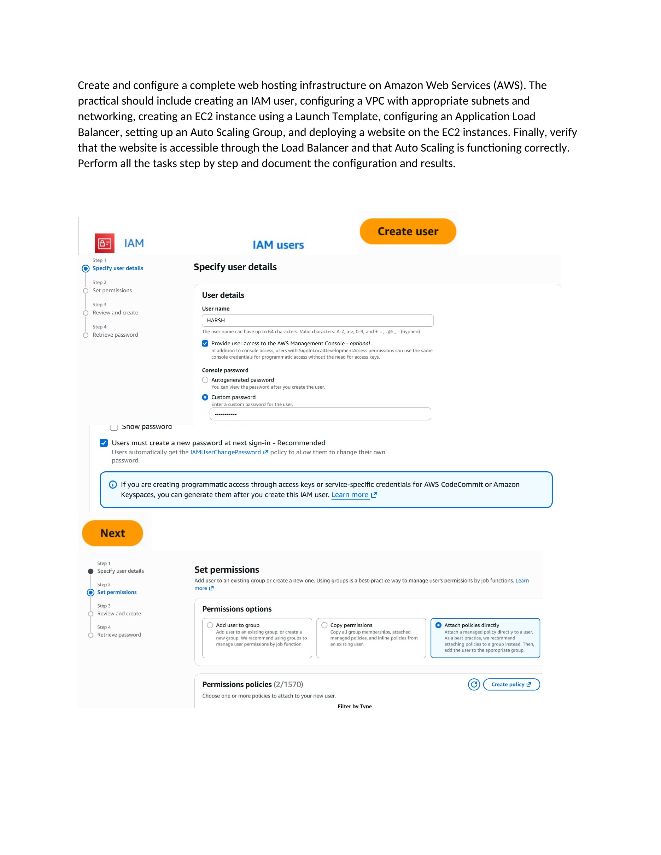
What I did: I entered the IAM user details, enabled console access, and moved to the permissions step.
Explanation: The screenshot shows the new IAM user being created and the permissions configuration being started.

PAGE 2 – IAM User – Select Permissions
Topic: IAM User – Select Permissions
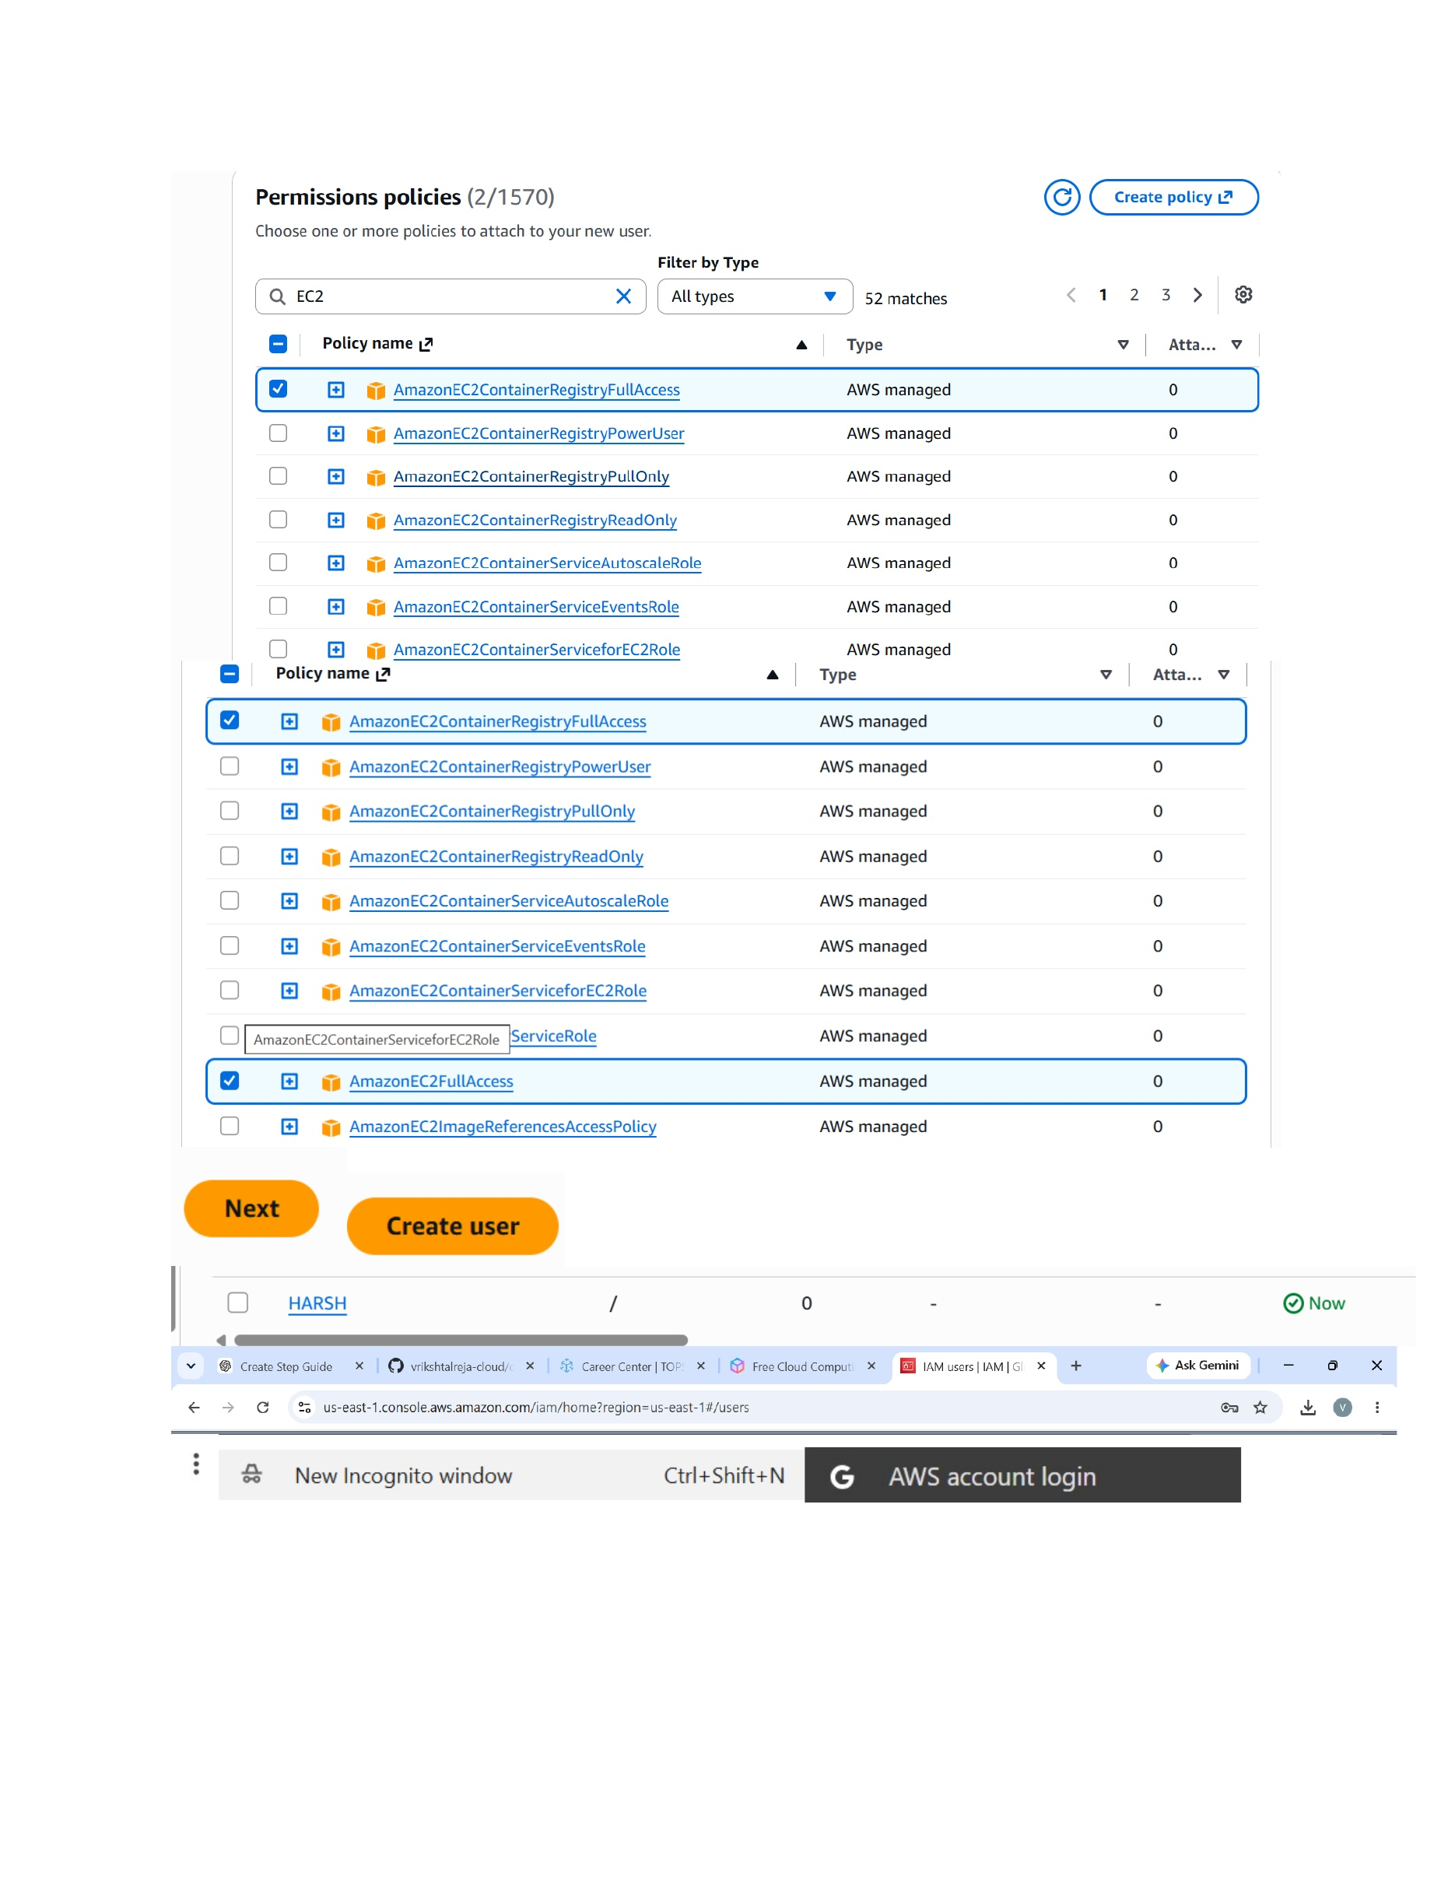
What I did: I reviewed the available AWS managed policies and selected the required permissions for the IAM user.
Explanation: The permissions page lists the policies that can be attached to the new user.

PAGE 3 – IAM – IAM User Sign-In
Topic: IAM – IAM User Sign-In
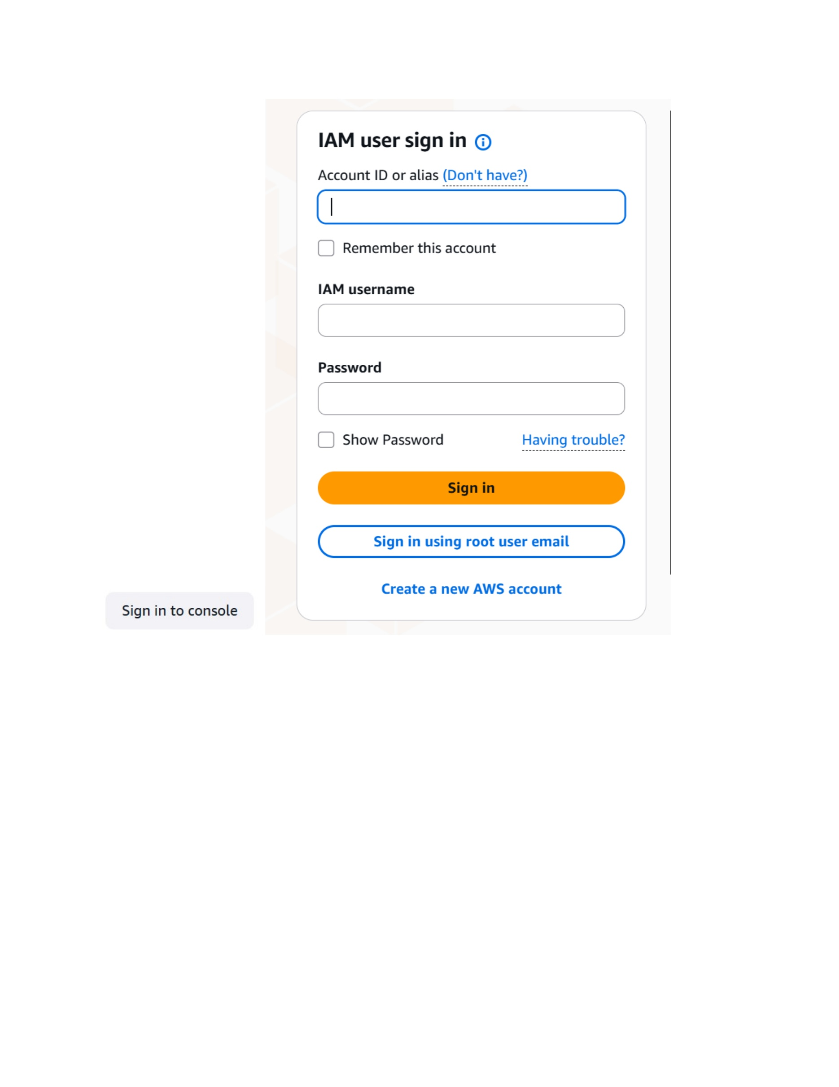
What I did: I opened the AWS IAM user sign-in page to log in with the created account.
Explanation: The sign-in page asks for the AWS account identifier/alias, IAM username, and password.

PAGE 4 – IAM – Enter User Credentials
Topic: IAM – Enter User Credentials
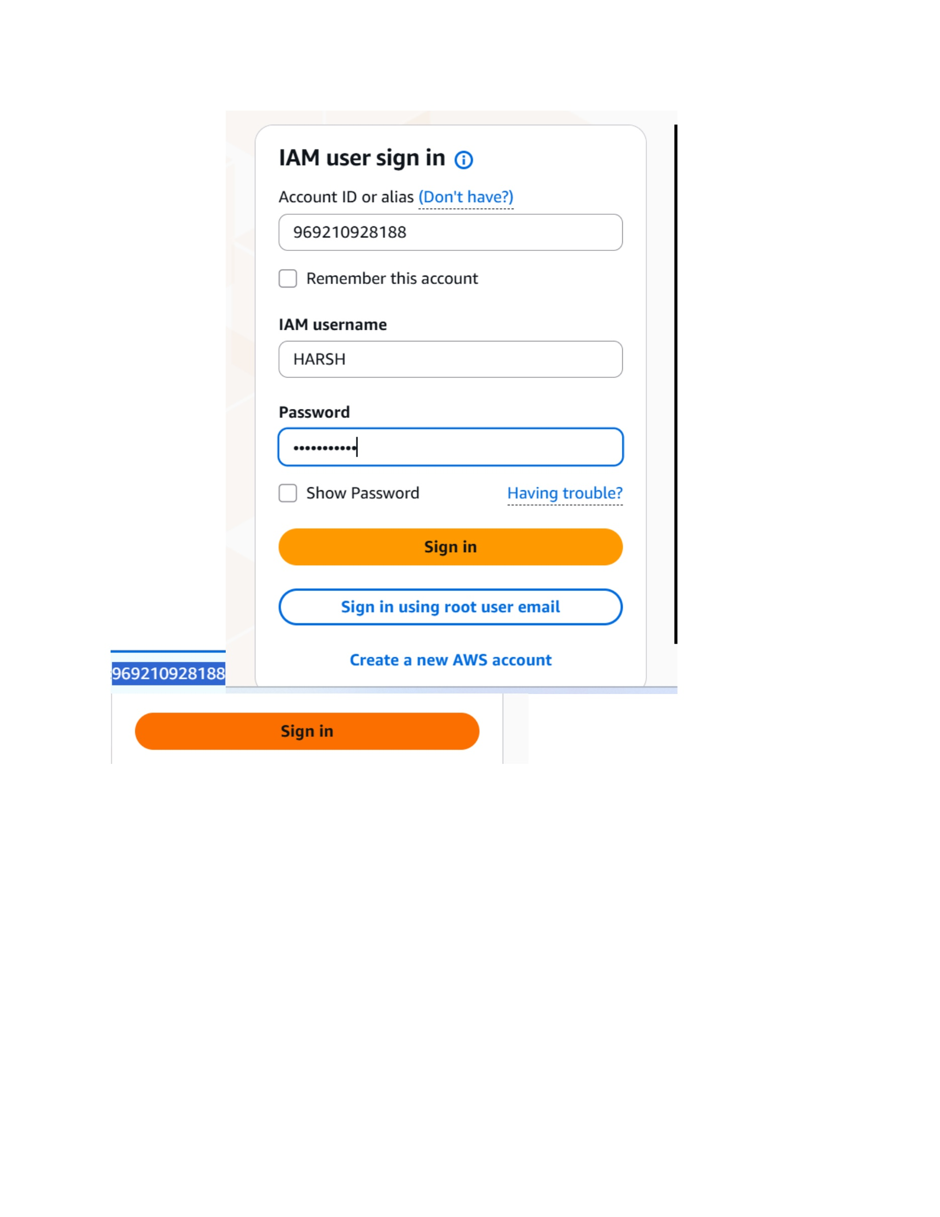
What I did: I entered the account ID and the IAM username HARSH on the AWS sign-in page.
Explanation: The screenshot shows the IAM credentials entered before signing in.

PAGE 5 – IAM – Reset User Password
Topic: IAM – Reset User Password
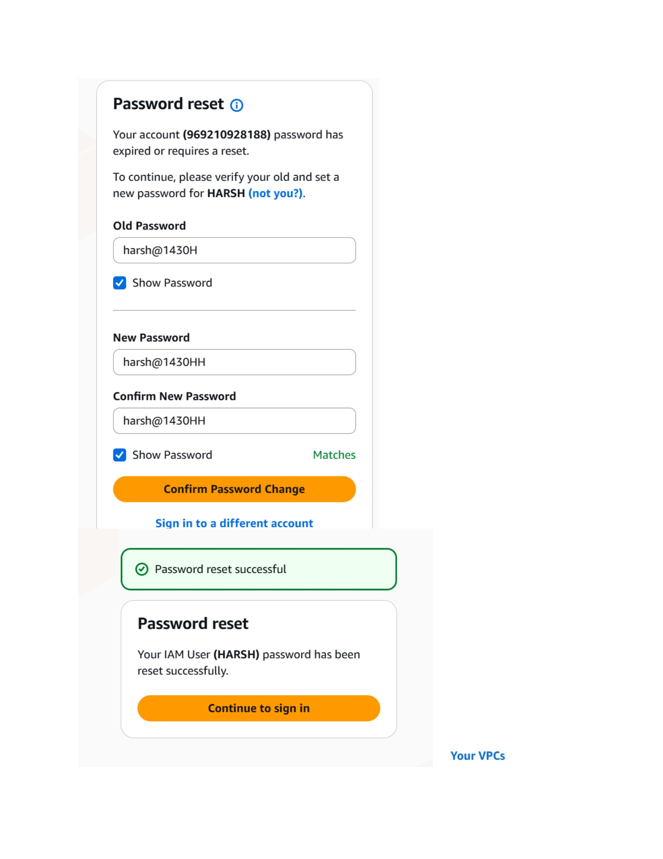
What I did: I completed the required password reset for the IAM user and confirmed the reset was successful.
Explanation: The screenshot shows the old/new password fields and the successful password-reset message.

PAGE 6 – VPC – Create the VPC
Topic: VPC – Create the VPC
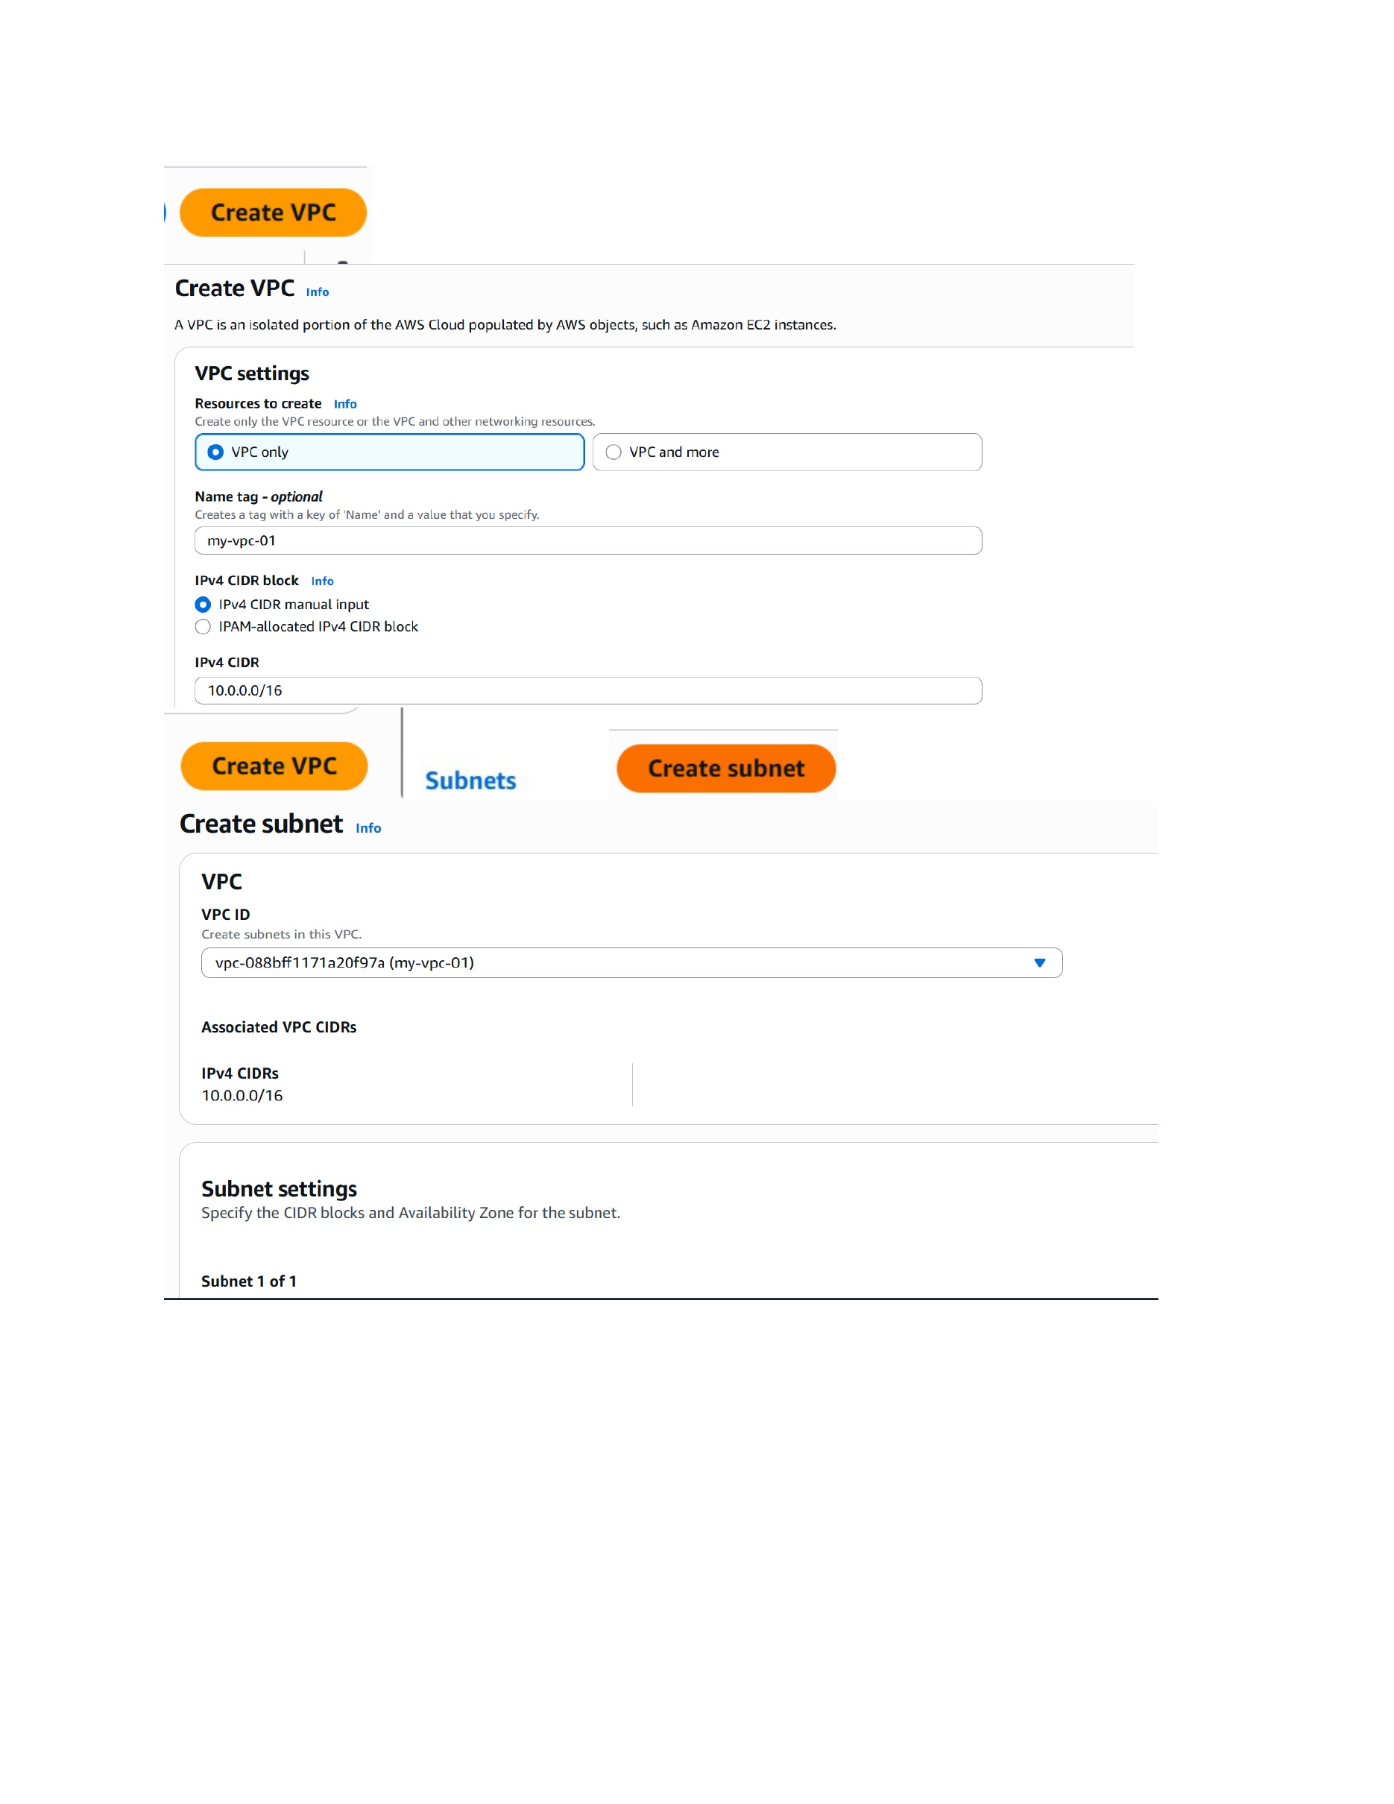
What I did: I created a VPC named my-vpc-01 and entered the IPv4 CIDR block 10.0.0.0/16.
Explanation: The VPC provides the isolated AWS network used by the web-hosting infrastructure.

PAGE 7 – VPC – Create the Public Subnet
Topic: VPC – Create the Public Subnet
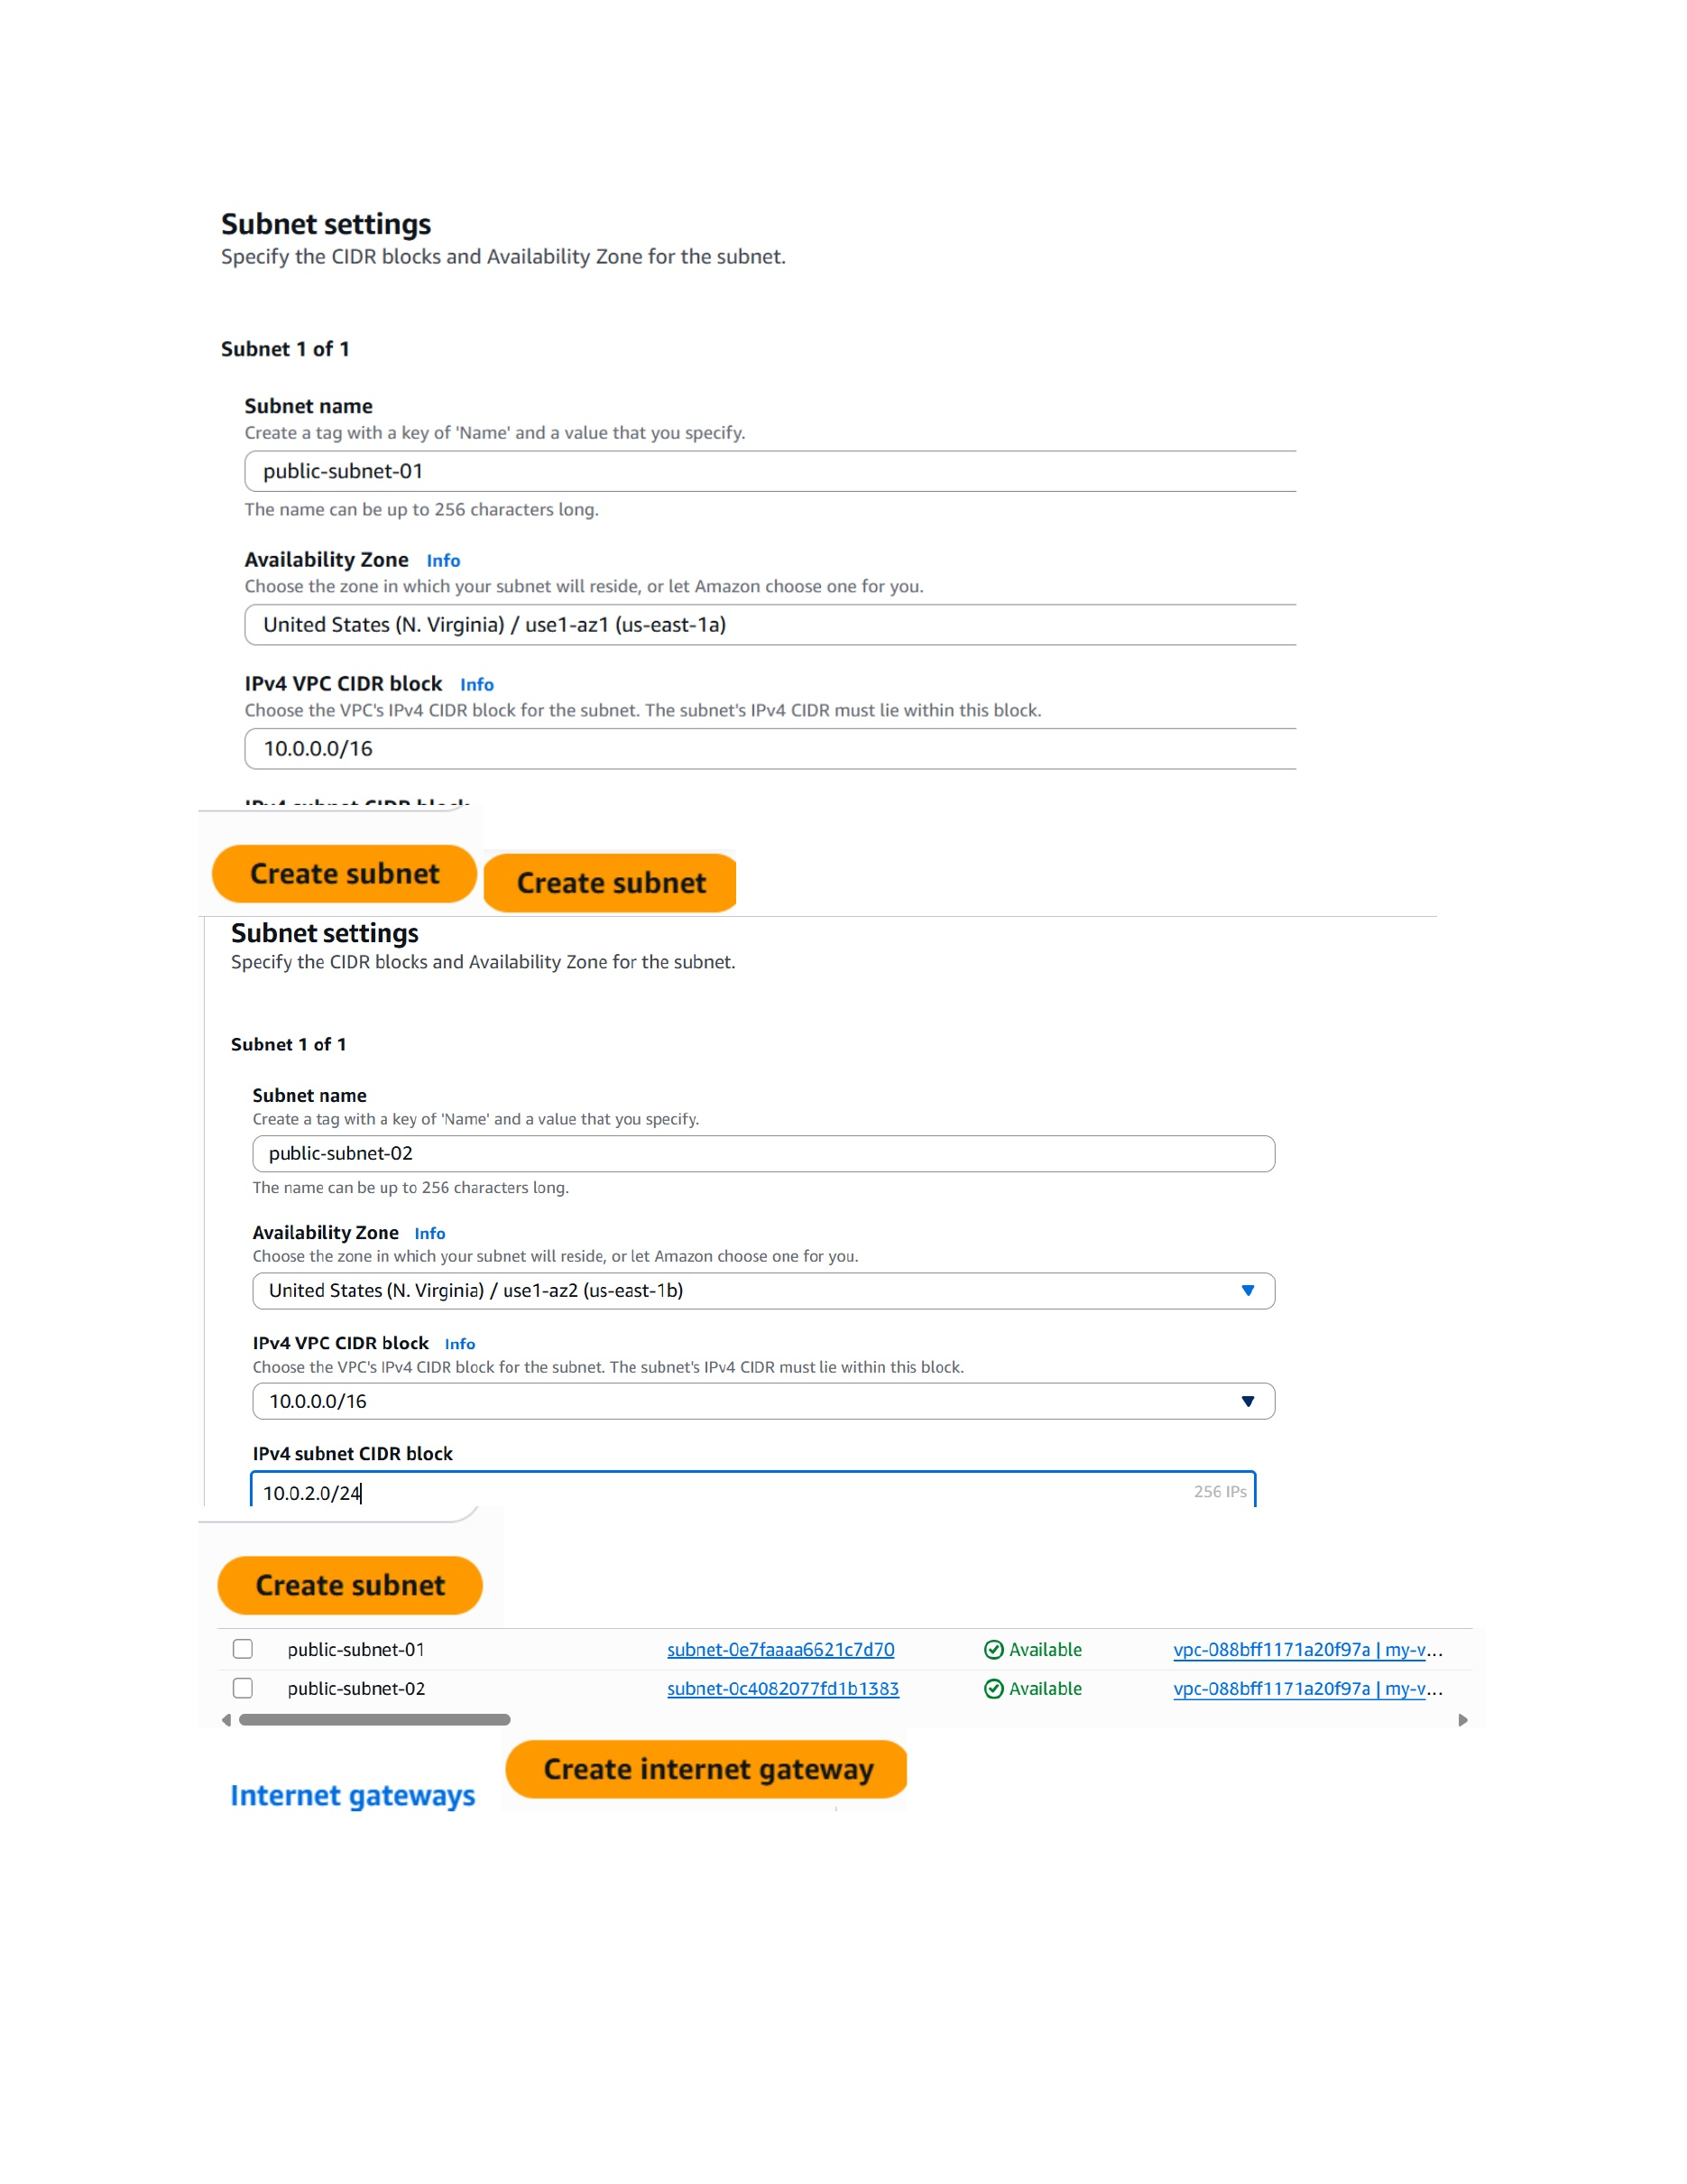
What I did: I created public-subnet-01 in the selected Availability Zone and used the VPC CIDR to define its subnet range.
Explanation: The subnet is configured inside the VPC for resources that need public network connectivity.

PAGE 8 – VPC – Create and Attach the Internet Gateway
Topic: VPC – Create and Attach the Internet Gateway
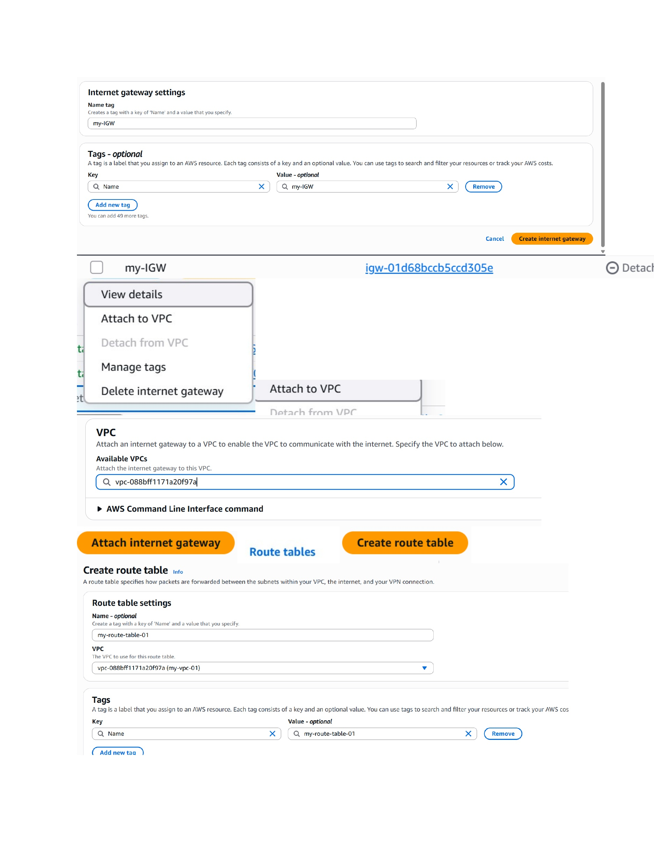
What I did: I created the Internet Gateway my-igw-01 and opened the option to attach it to the VPC.
Explanation: The Internet Gateway provides the VPC with a path to the internet.

PAGE 9 – VPC – Configure the Route Table
Topic: VPC – Configure the Route Table
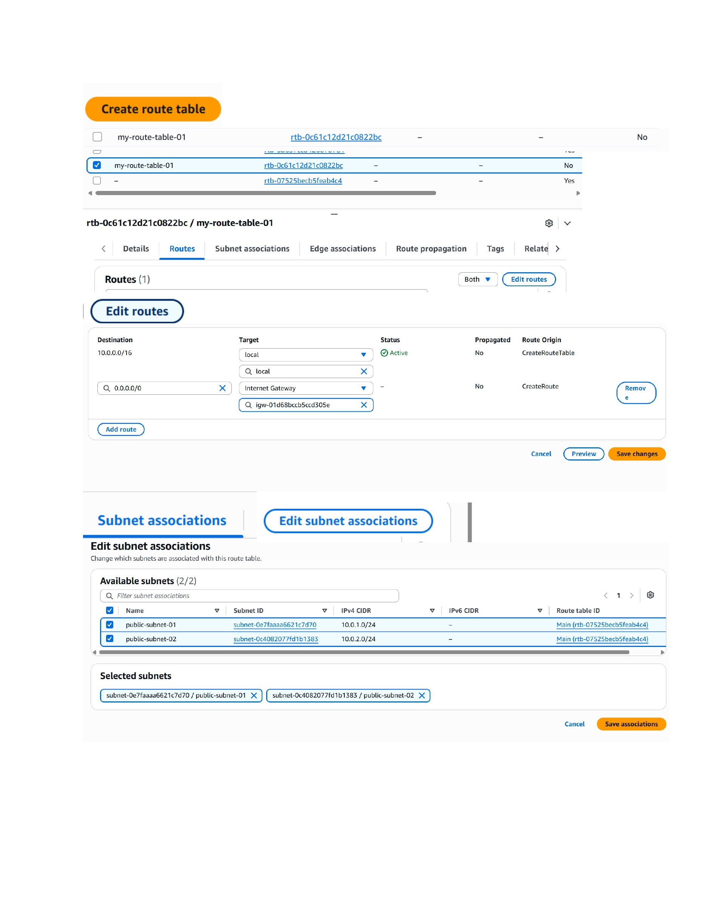
What I did: I created/configured my-route-table-01 and added the default route 0.0.0.0/0 through the Internet Gateway.
Explanation: The route table sends internet-bound traffic from the associated subnet toward the Internet Gateway.

PAGE 10 – EC2 – Open the EC2 Dashboard
Topic: EC2 – Open the EC2 Dashboard
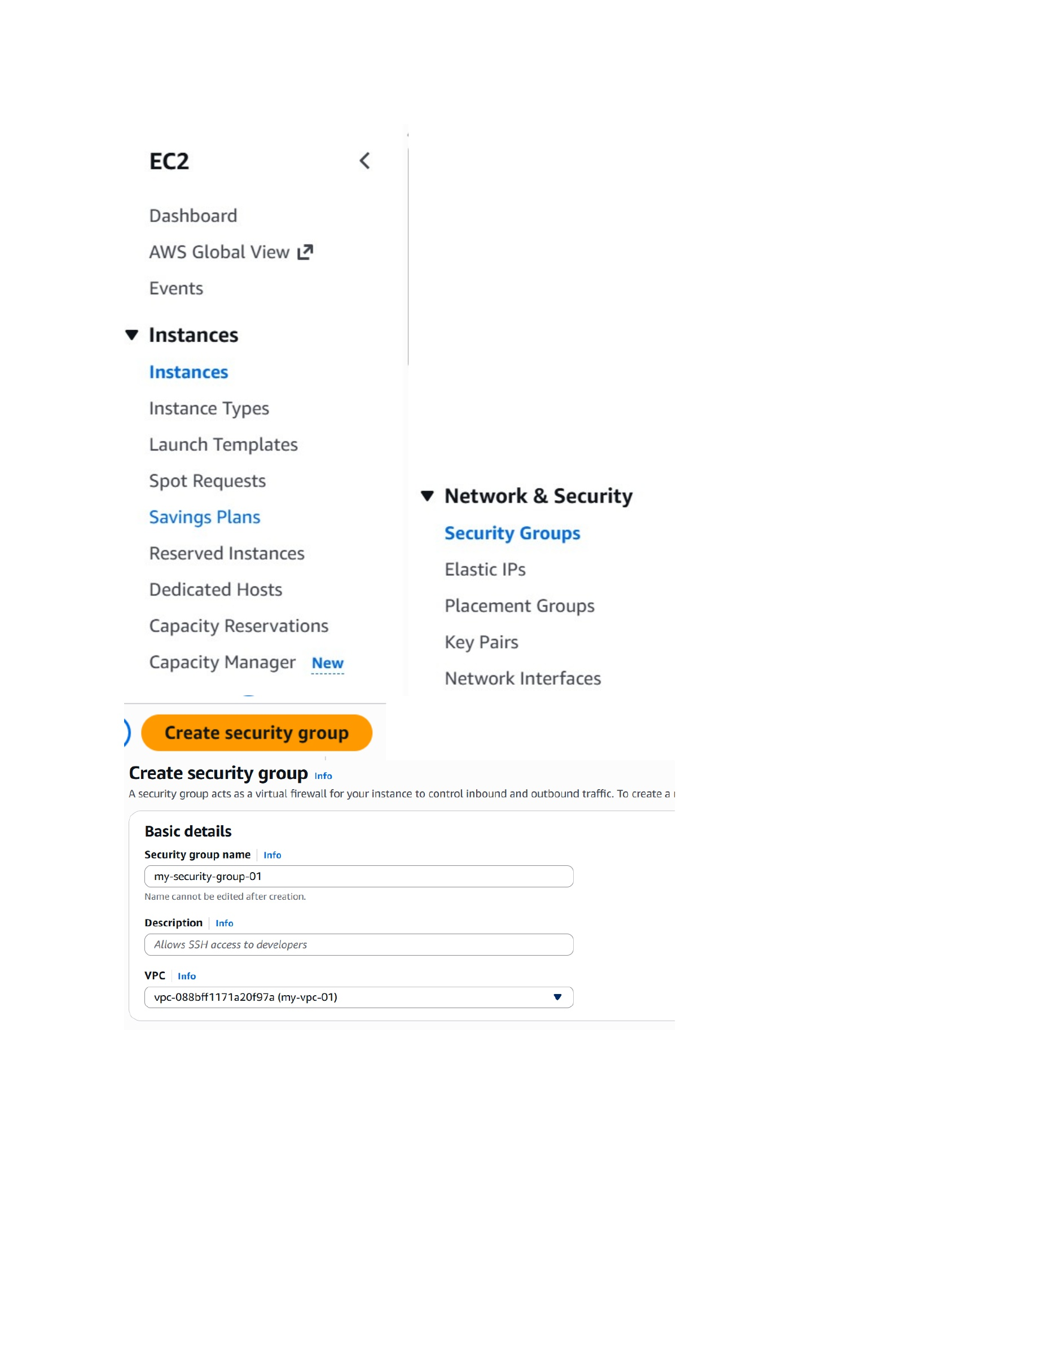
What I did: I opened the EC2 console and navigated to the Instances and Launch Templates sections.
Explanation: This is the EC2 management area used to create the instance template and launch the web server.

PAGE 11 – Security Group – Configure Inbound Rules and Start Launch Template
Topic: Security Group – Configure Inbound Rules and Start Launch Template
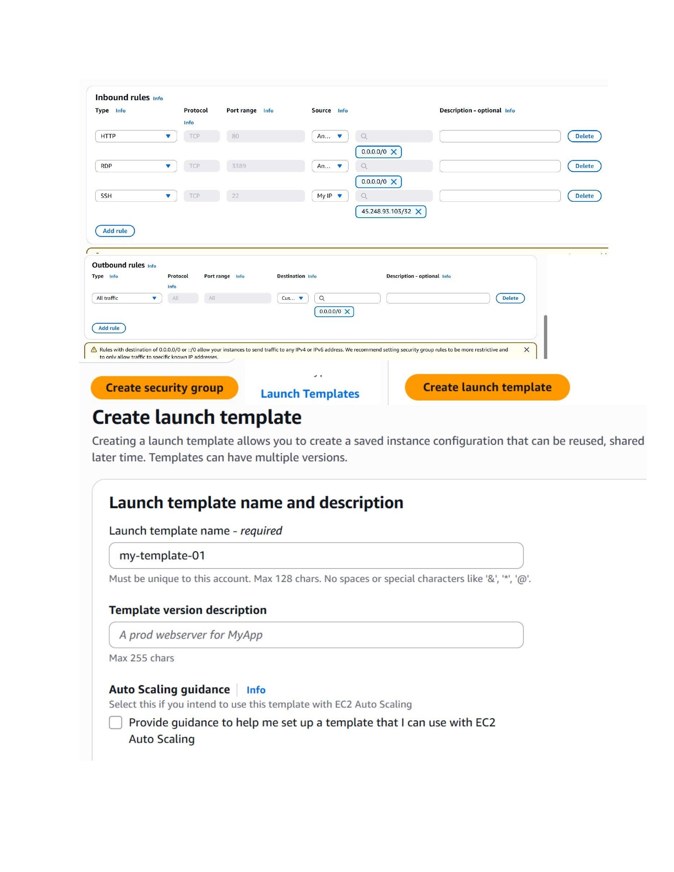
What I did: I configured the security-group inbound rules and started creating the launch template my-template-01.
Explanation: The screenshot shows the firewall rule configuration followed by the launch-template setup.

PAGE 12 – Launch Template – Select AMI and Instance Type
Topic: Launch Template – Select AMI and Instance Type
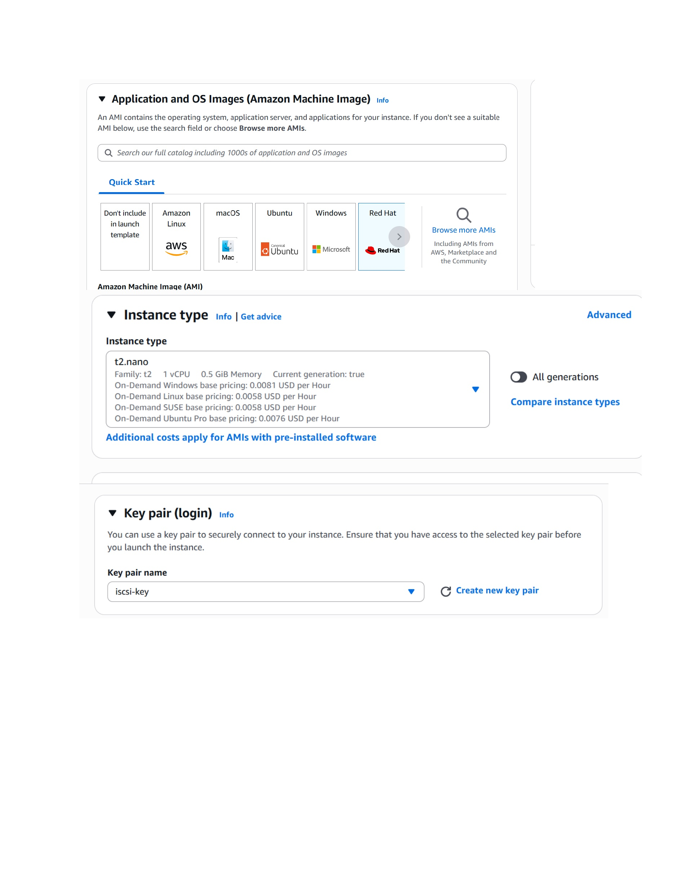
What I did: I selected the Amazon Machine Image and the t2.nano instance type for the launch template.
Explanation: These settings define the operating system image and compute size for instances launched from the template.

PAGE 13 – Launch Template – Configure Network and User Data
Topic: Launch Template – Configure Network and User Data
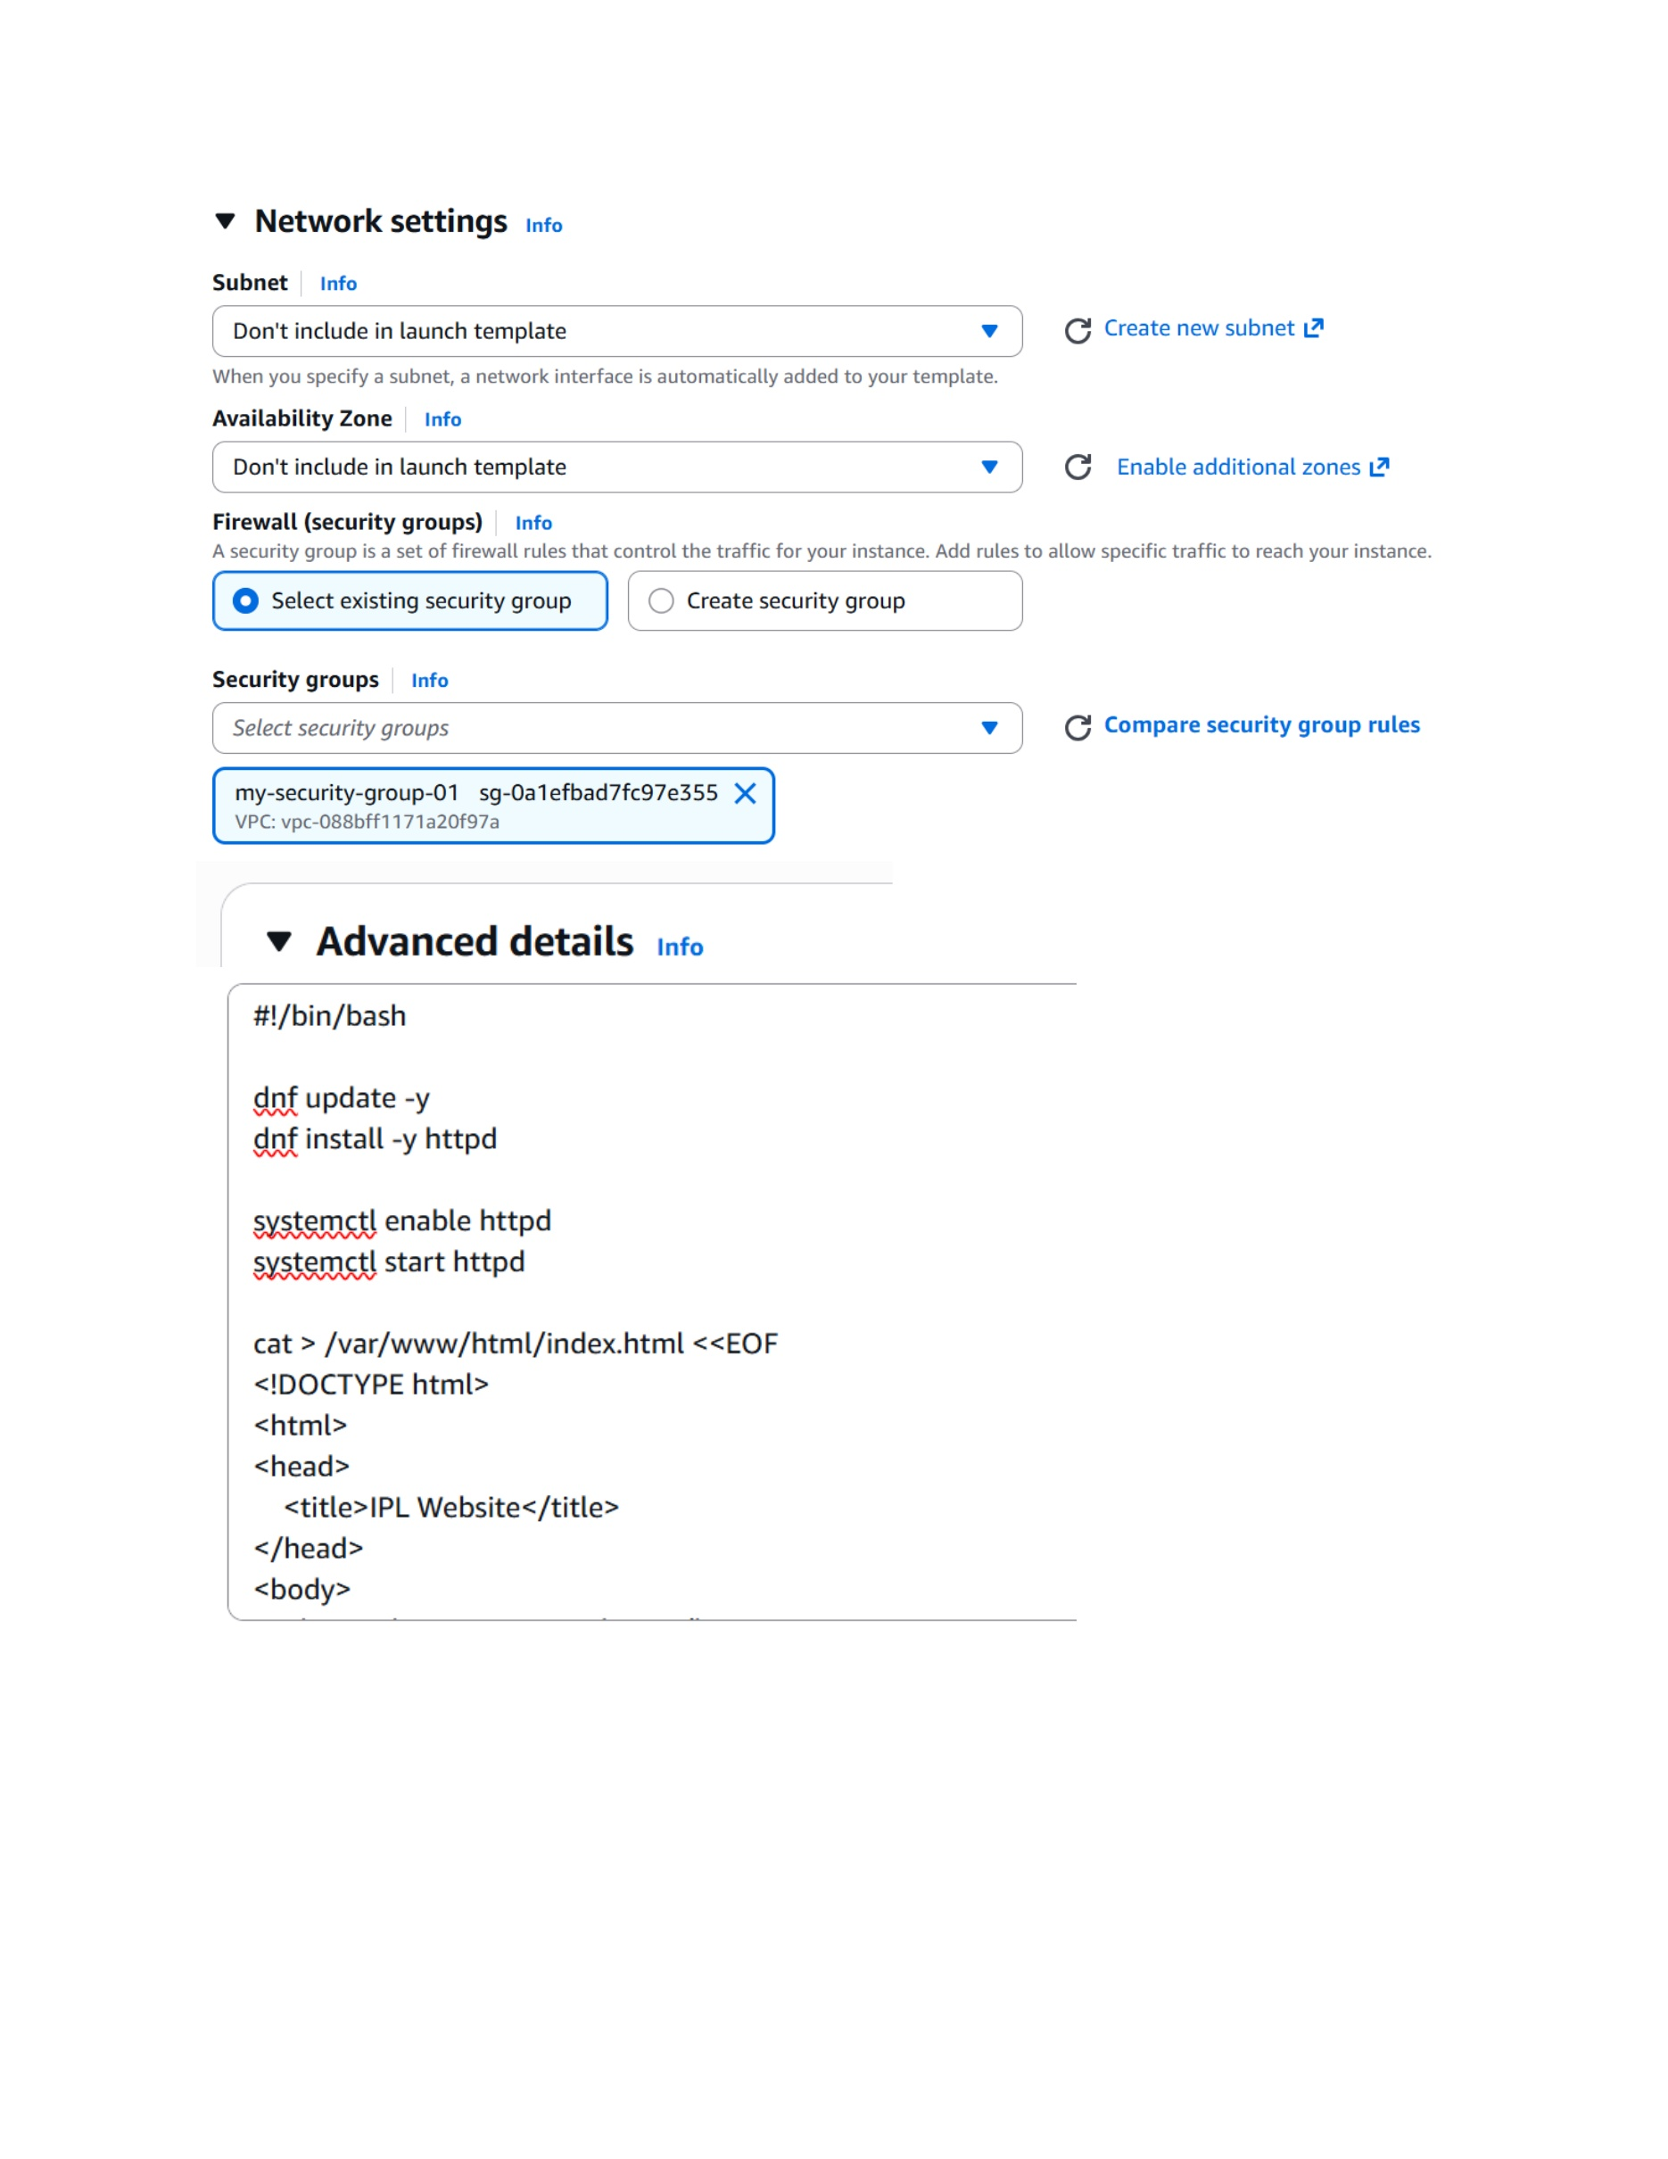
What I did: I selected the VPC/subnet and security group and entered the startup script to install and start httpd and create the IPL website.
Explanation: The user-data script prepares each EC2 instance as a web server automatically when it launches.

PAGE 14 – Target Group – Start Creating the Target Group
Topic: Target Group – Start Creating the Target Group
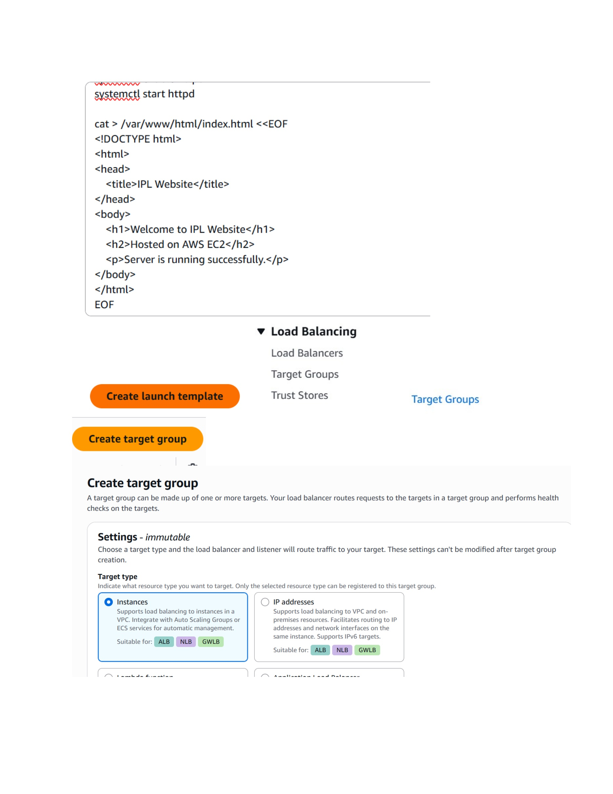
What I did: I opened Load Balancing > Target Groups and started creating a target group for the EC2 instances.
Explanation: The target group is used by the load balancer to route requests to registered instances.

PAGE 15 – Target Group – Configure Basic Settings
Topic: Target Group – Configure Basic Settings
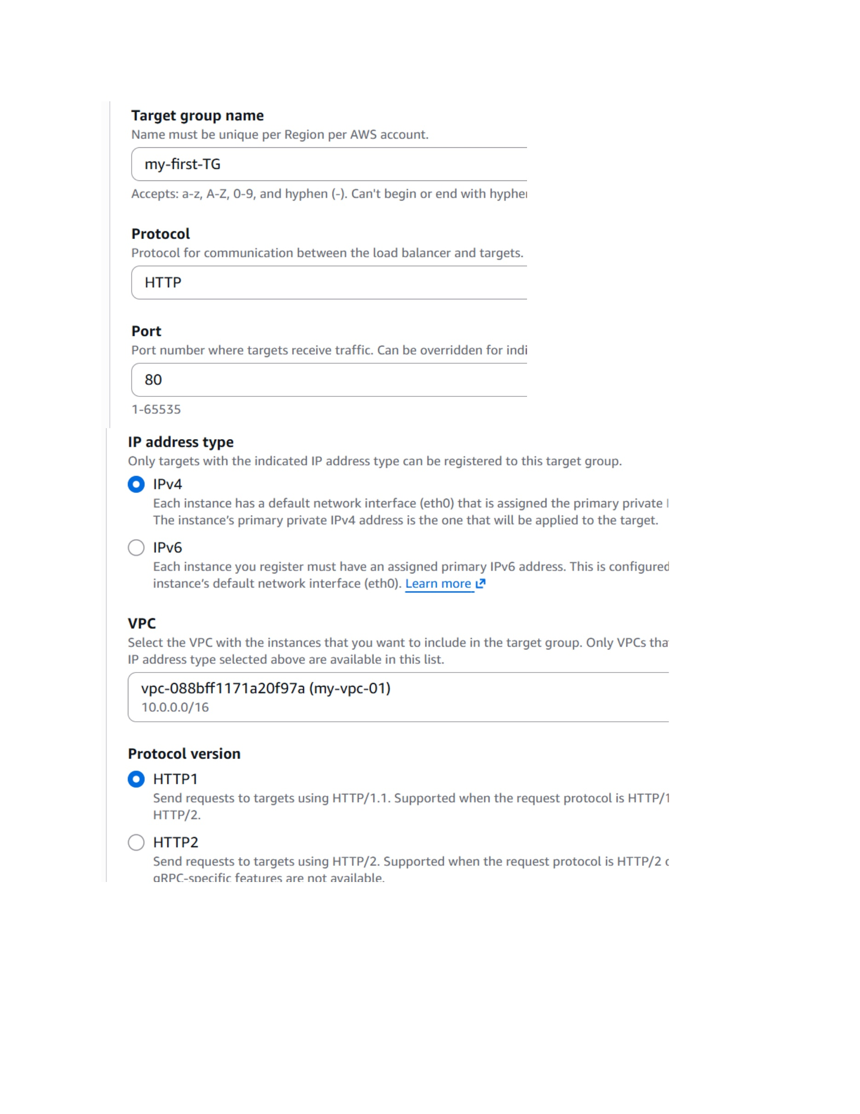
What I did: I entered the target group name my-first-TG, selected HTTP on port 80, IPv4, and the my-vpc-01 VPC.
Explanation: These settings define how the load balancer communicates with the web-server targets.

PAGE 16 – Target Group – Configure Health Checks
Topic: Target Group – Configure Health Checks
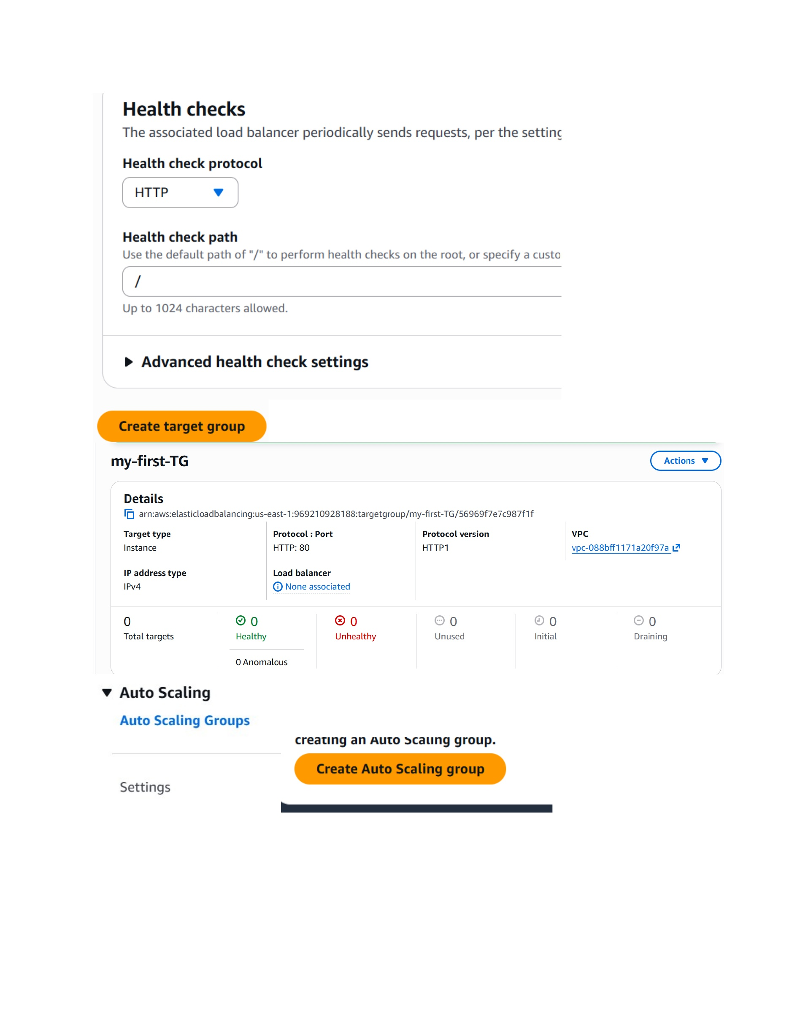
What I did: I configured the HTTP health check and reviewed the target group details and health-check status.
Explanation: The health check allows the load balancer to determine whether the registered EC2 instances are healthy.

PAGE 17 – Auto Scaling Group – Choose Launch Template
Topic: Auto Scaling Group – Choose Launch Template
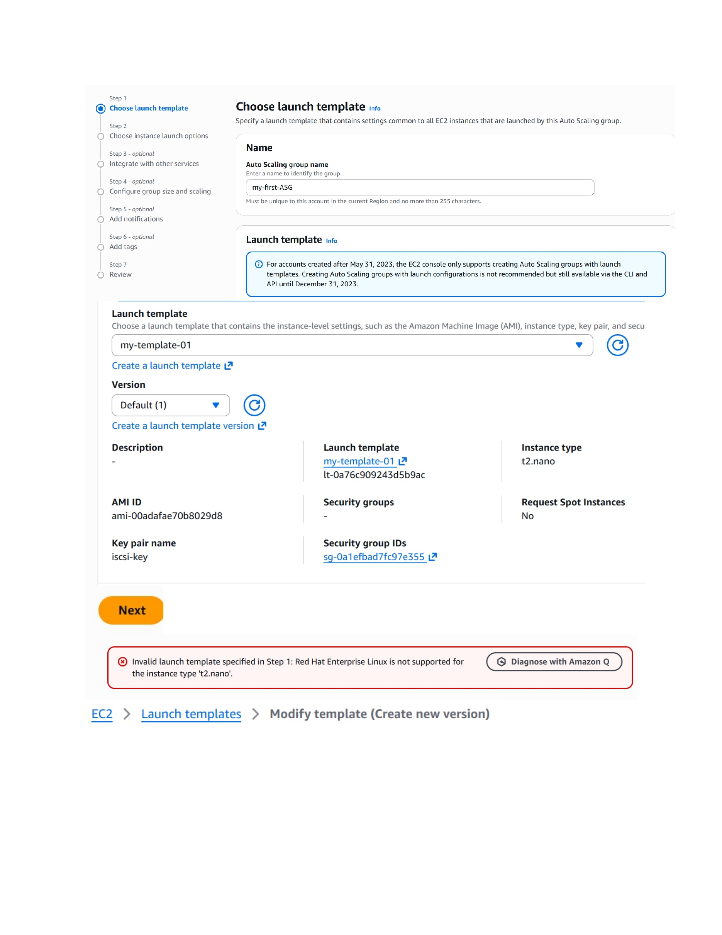
What I did: I started creating the Auto Scaling Group and selected my-template-01 as the launch template.
Explanation: The ASG will use this template when launching EC2 instances.

PAGE 18 – Launch Template – Review Version and AMI
Topic: Launch Template – Review Version and AMI
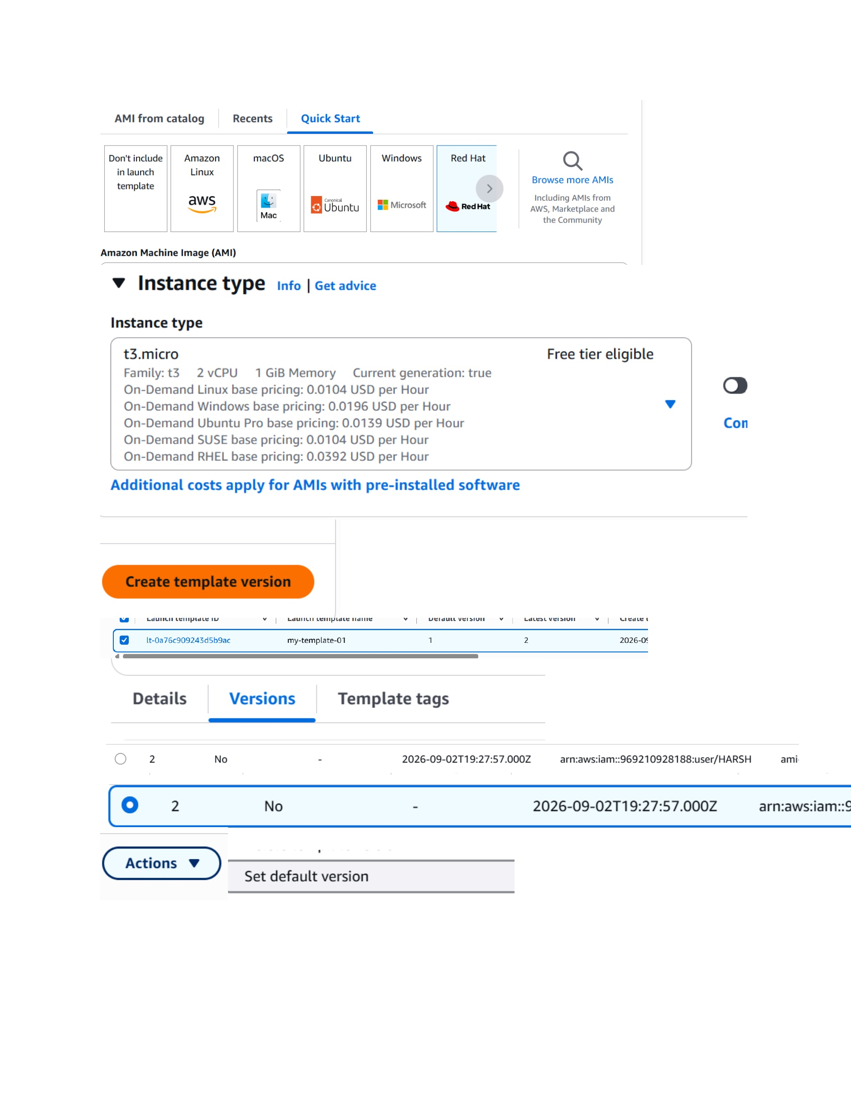
What I did: I reviewed the launch-template version and the selected AMI/instance configuration.
Explanation: The template version contains the instance settings that will be reused by the Auto Scaling Group.

PAGE 19 – Launch Template – Set Default Version
Topic: Launch Template – Set Default Version
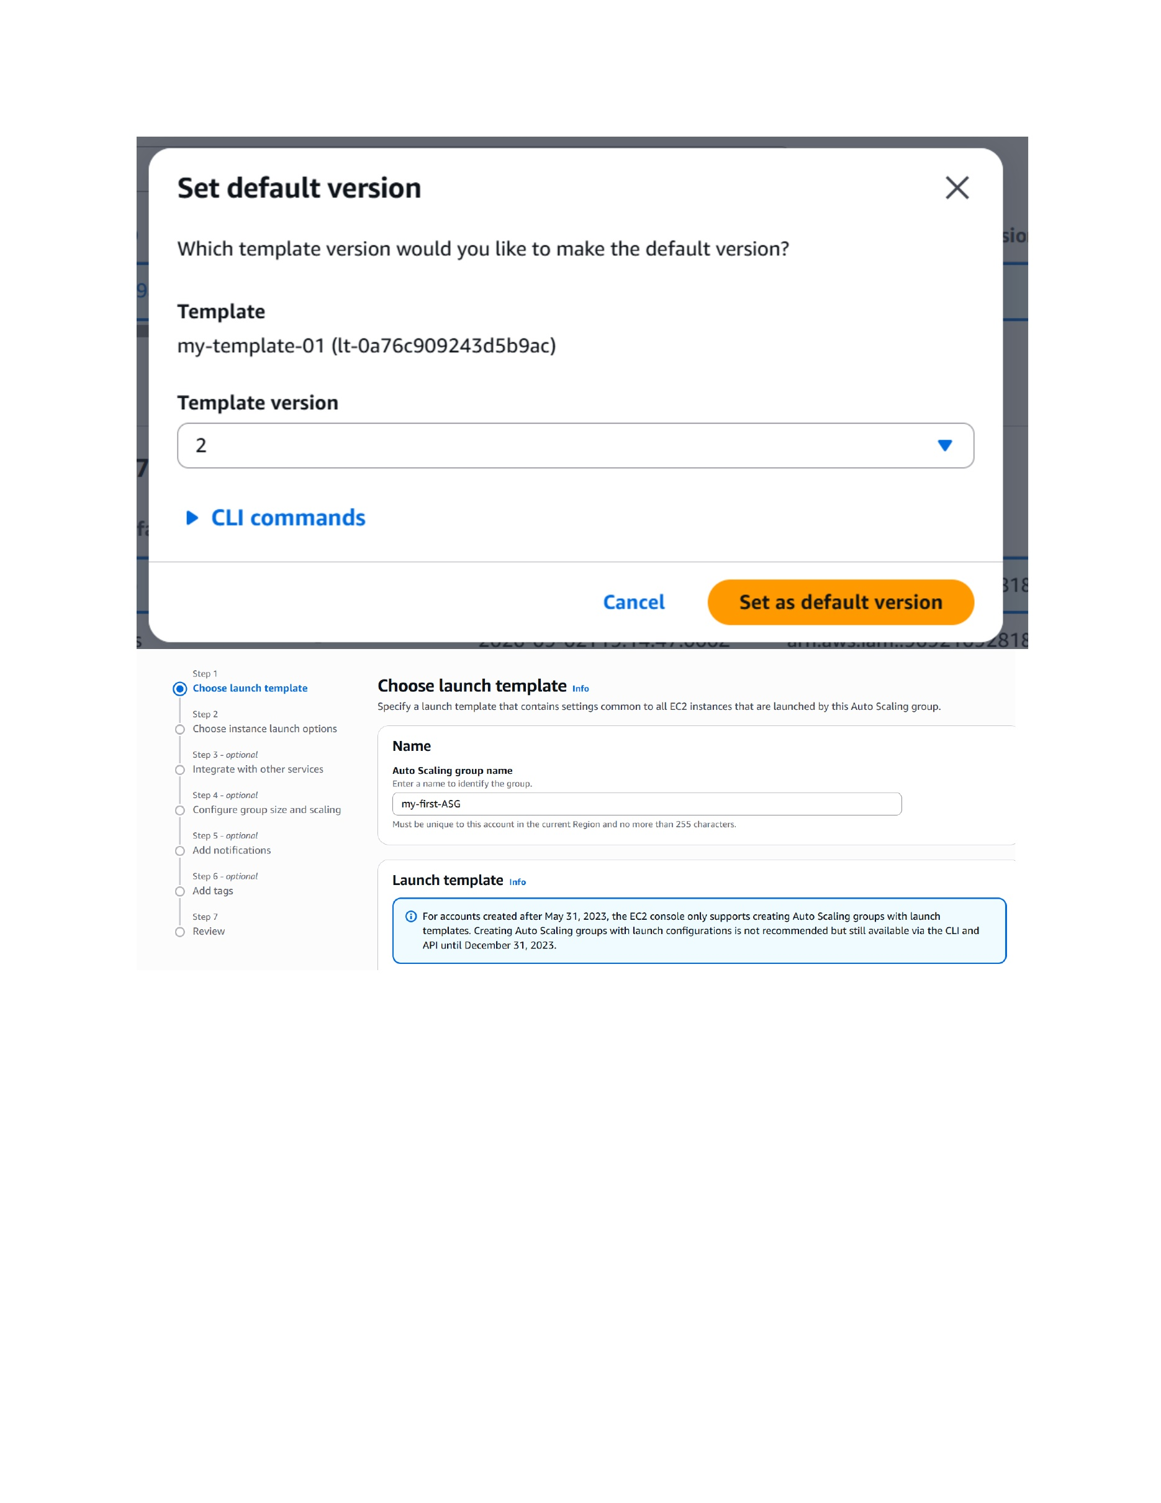
What I did: I selected the required template version and set it as the default version for my-template-01.
Explanation: The default version is the version used when the launch template is referenced without another version.

PAGE 20 – Auto Scaling Group – Select Launch Template Version
Topic: Auto Scaling Group – Select Launch Template Version
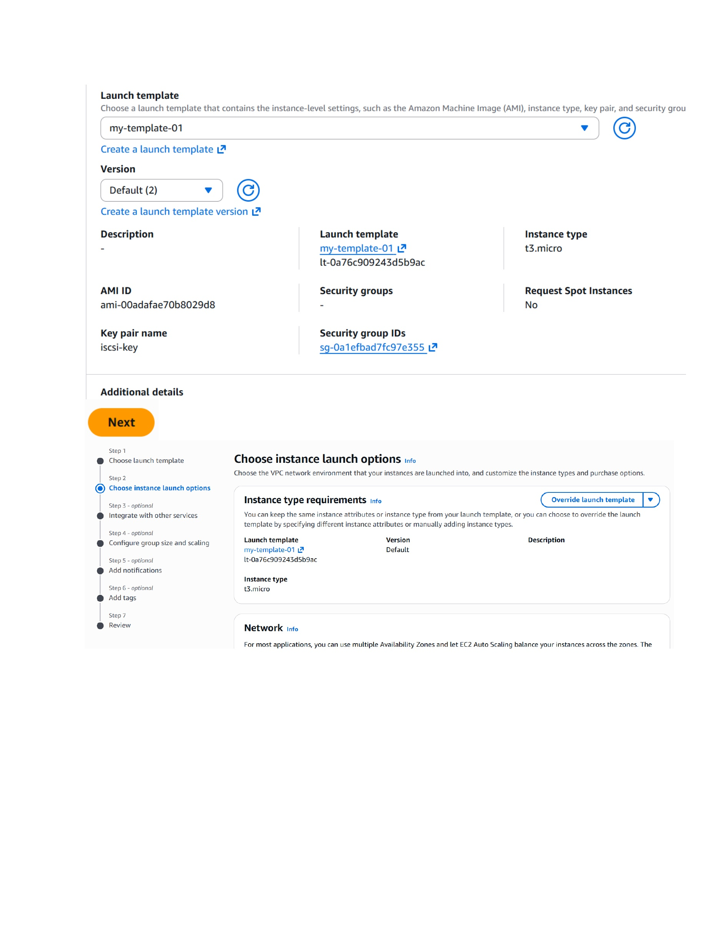
What I did: I selected my-template-01 with its default version while configuring the Auto Scaling Group.
Explanation: The ASG is now tied to the saved EC2 instance configuration.

PAGE 21 – Auto Scaling Group – Configure VPC and Subnets
Topic: Auto Scaling Group – Configure VPC and Subnets
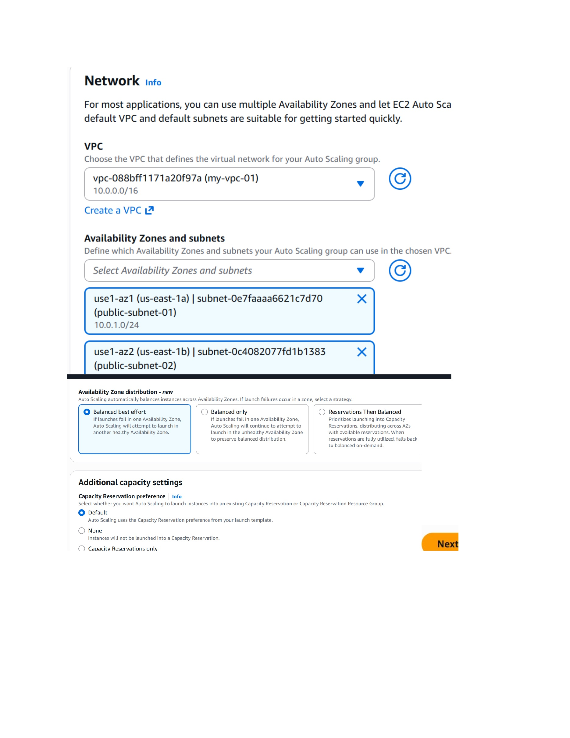
What I did: I selected my-vpc-01 and the public subnets in us-east-1a and us-east-1b.
Explanation: The ASG can launch instances across the selected Availability Zones and subnets.

PAGE 22 – Auto Scaling Group – Configure Load Balancing
Topic: Auto Scaling Group – Configure Load Balancing
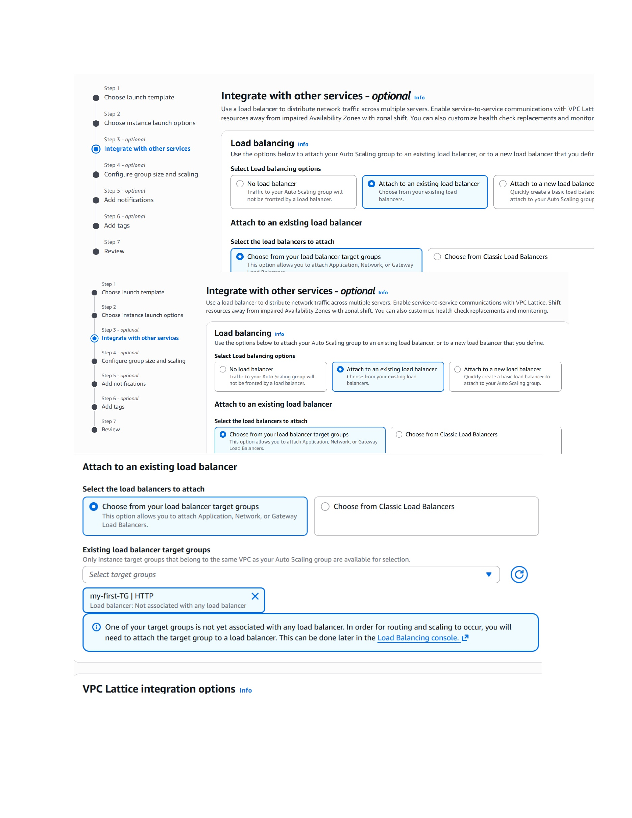
What I did: I opened the load-balancing options and configured the ASG integration with the load balancer/target group.
Explanation: This connects the Auto Scaling Group to the traffic-distribution layer.

PAGE 23 – Auto Scaling Group – Configure Health Checks
Topic: Auto Scaling Group – Configure Health Checks
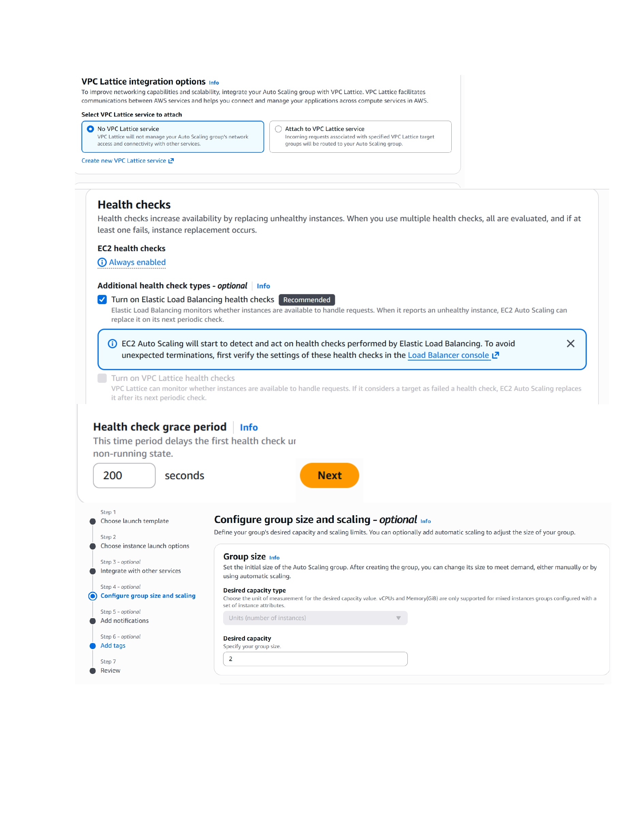
What I did: I reviewed the EC2 health check and enabled the Elastic Load Balancing health check option.
Explanation: The ASG can use load-balancer health information to replace unhealthy instances.

PAGE 24 – Auto Scaling Group – Configure Scaling
Topic: Auto Scaling Group – Configure Scaling
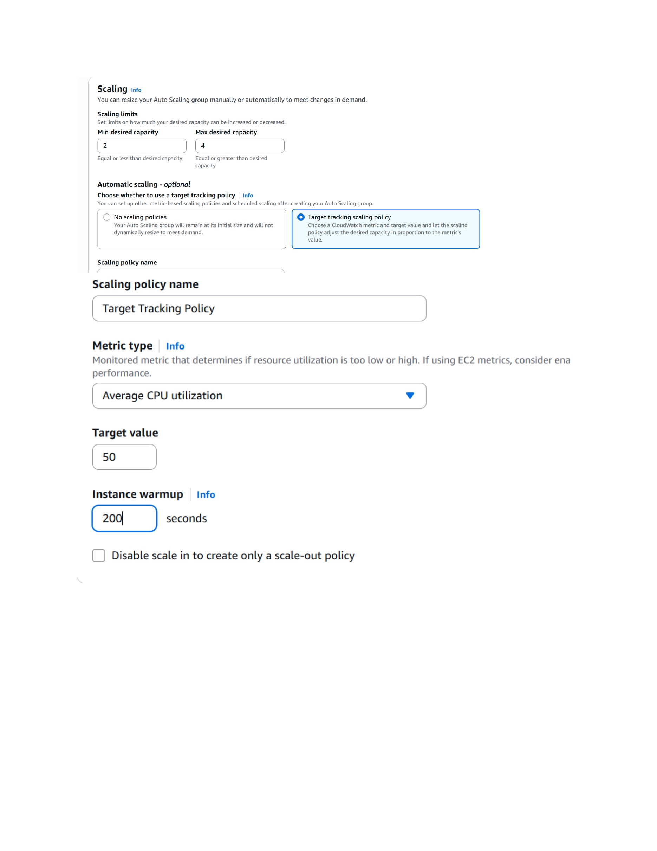
What I did: I set the minimum/desired/max capacity and configured target tracking using average CPU utilization.
Explanation: These settings control how many instances run and when the ASG scales based on CPU usage.

PAGE 25 – Auto Scaling Group – Configure Instance Maintenance
Topic: Auto Scaling Group – Configure Instance Maintenance
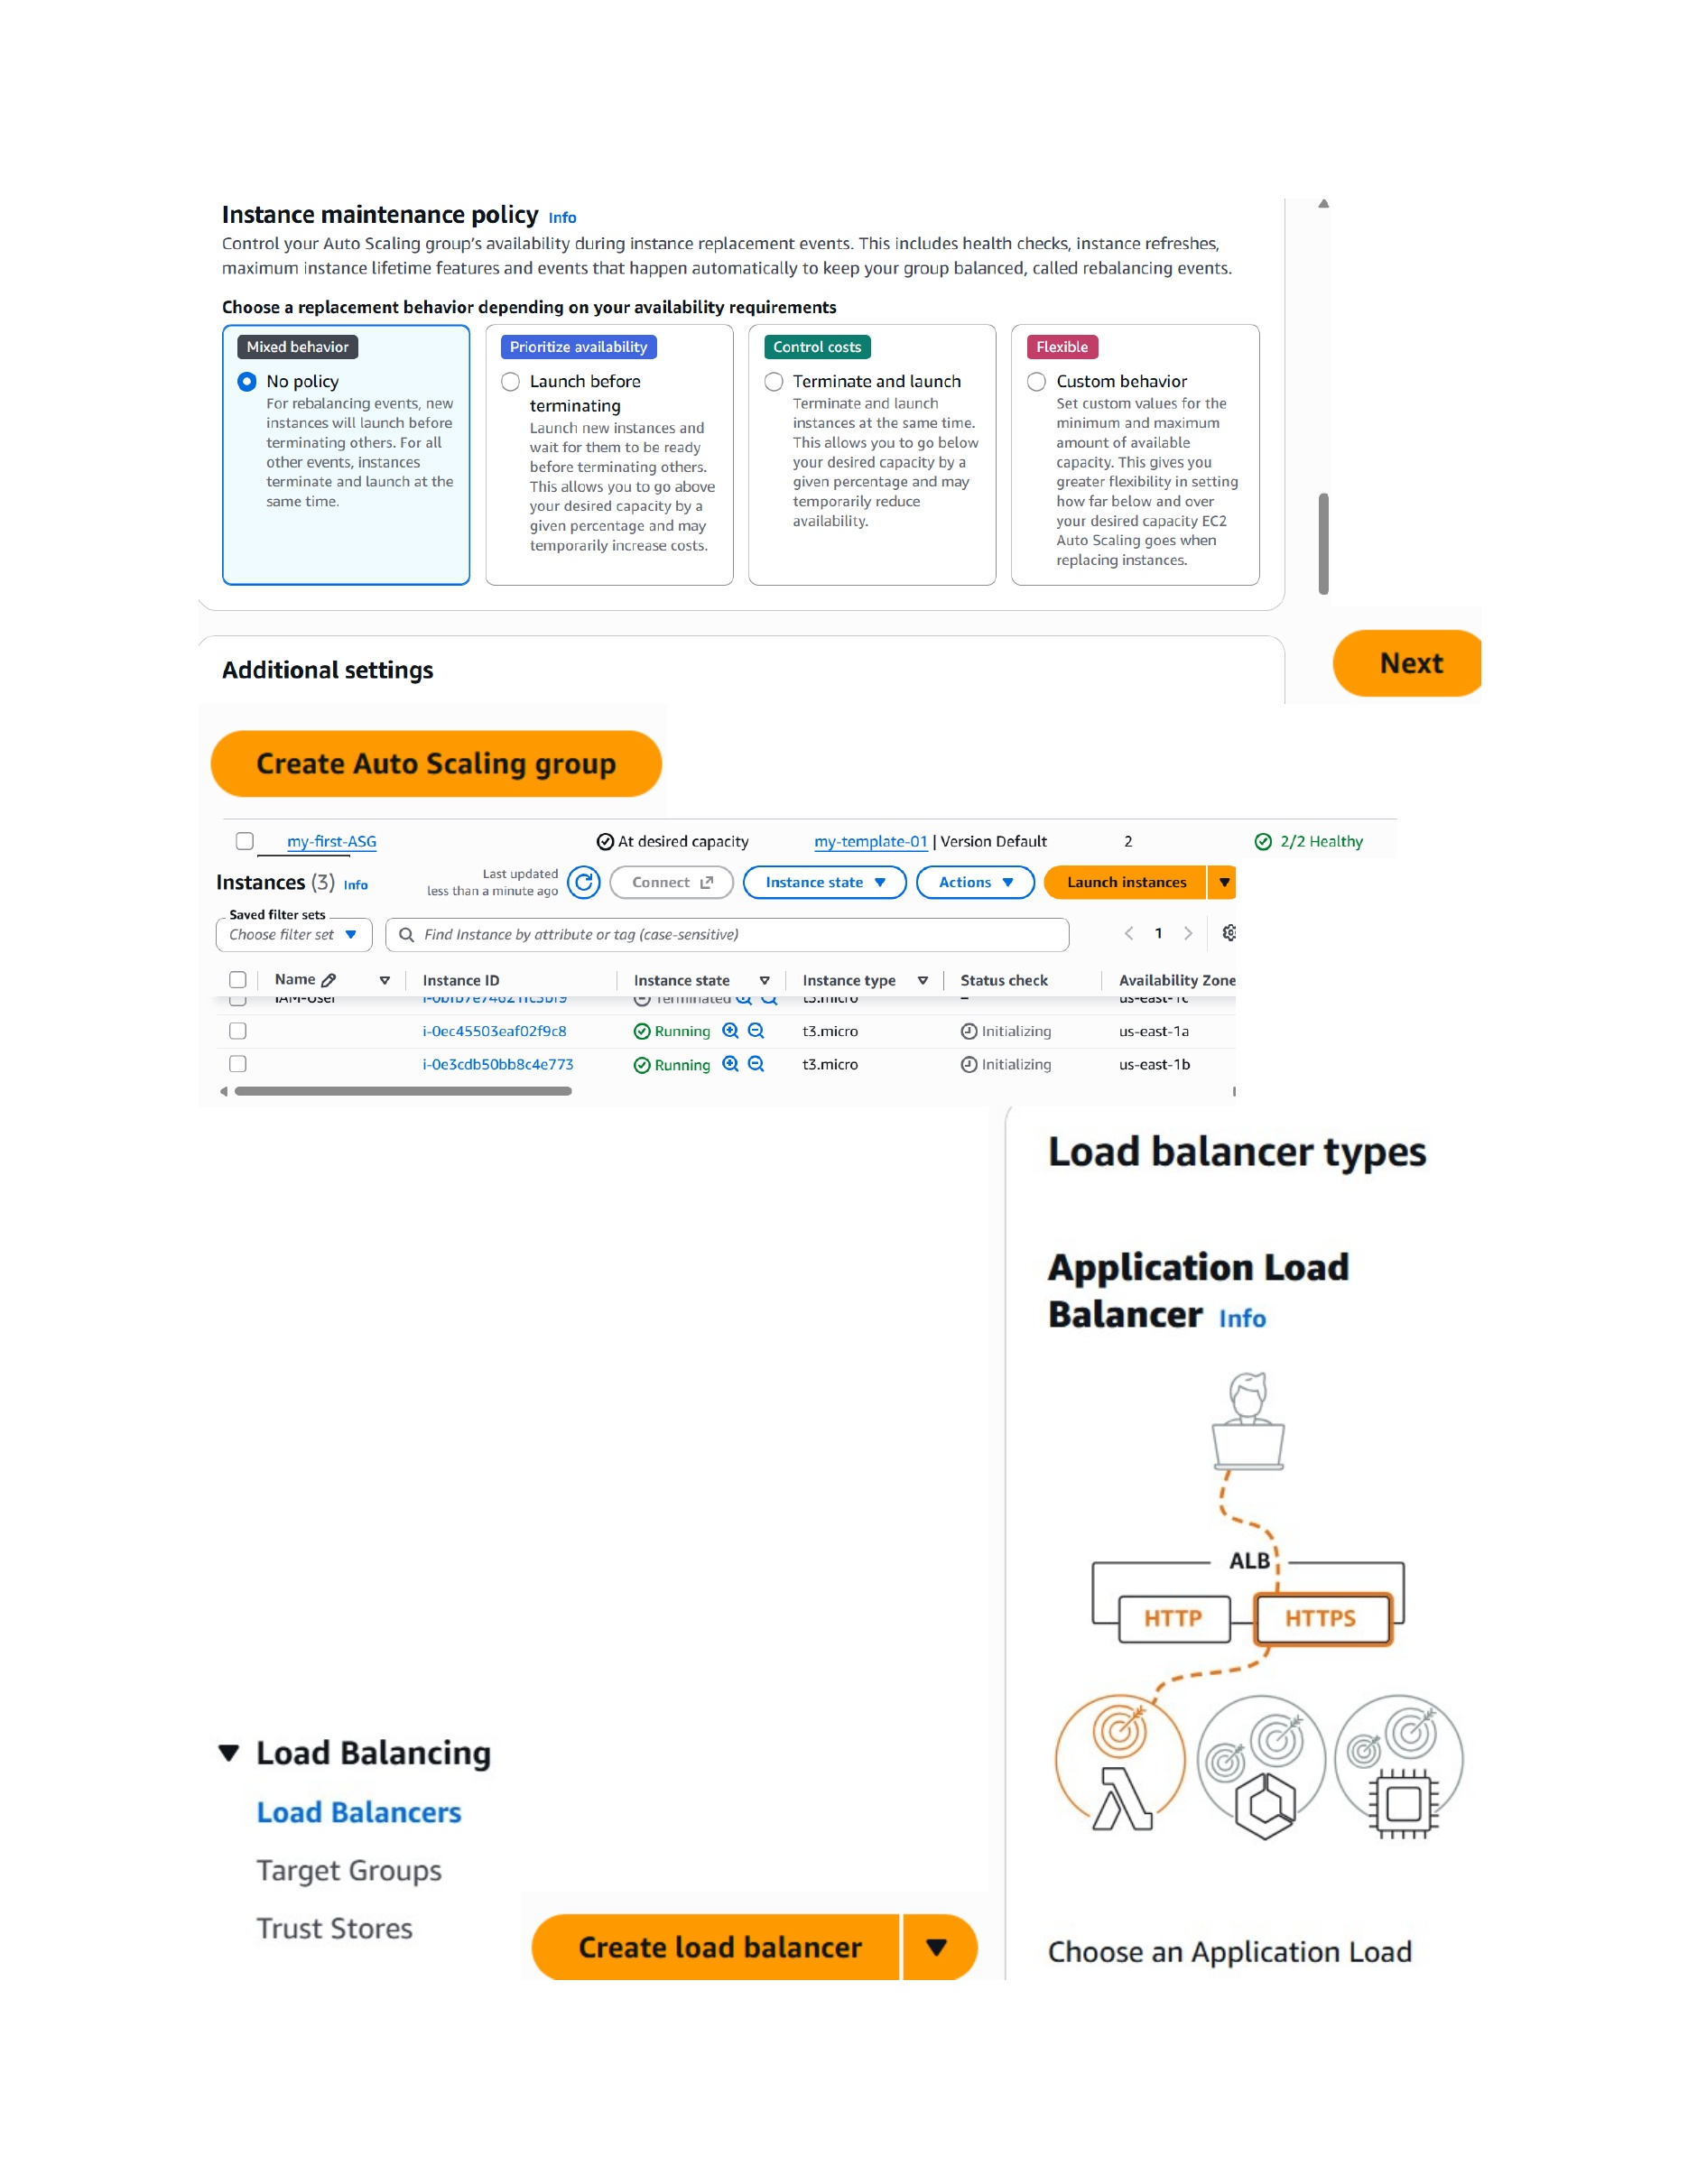
What I did: I reviewed the instance maintenance/replacement policy options for the Auto Scaling Group.
Explanation: The selected maintenance behavior controls how instances are replaced during refresh and rebalancing events.

PAGE 26 – Application Load Balancer – Configure Basic Settings
Topic: Application Load Balancer – Configure Basic Settings
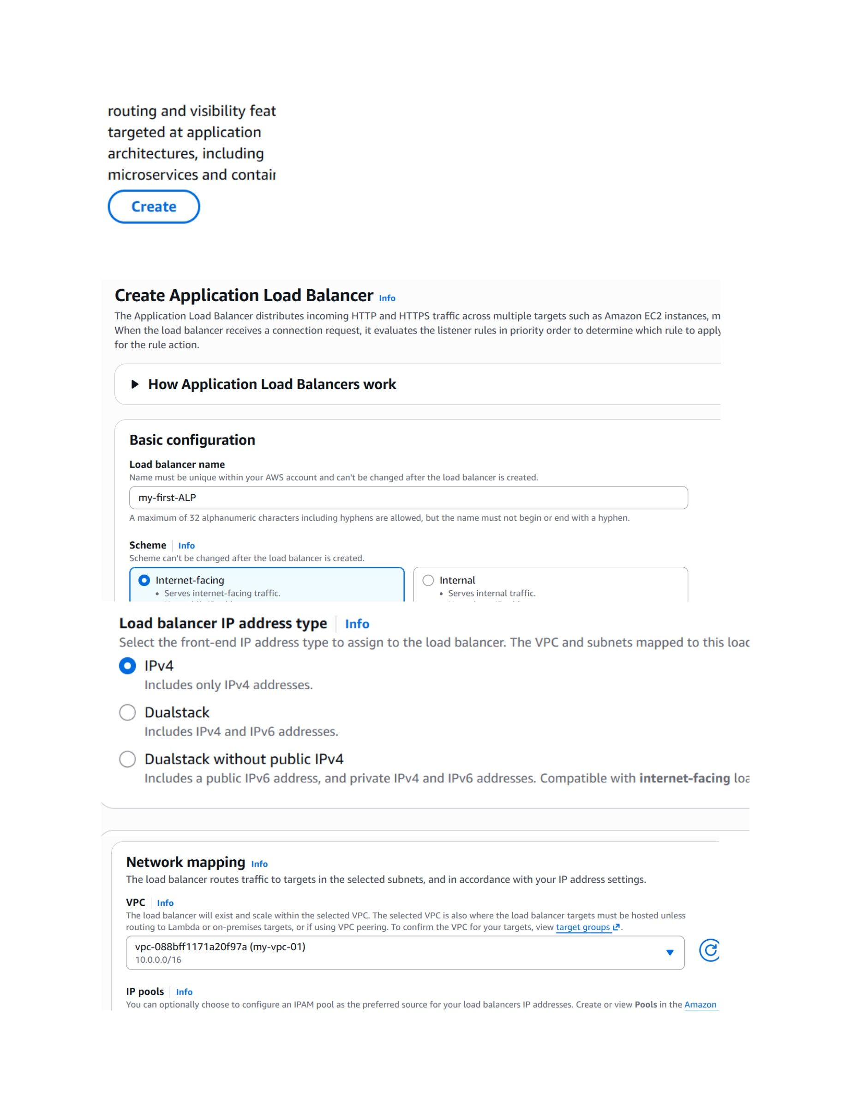
What I did: I started creating an Application Load Balancer named my-first-ALB and selected an internet-facing configuration.
Explanation: The ALB distributes incoming HTTP/HTTPS traffic to targets such as the EC2 instances.

PAGE 27 – Application Load Balancer – Select Availability Zones and Subnets
Topic: Application Load Balancer – Select Availability Zones and Subnets
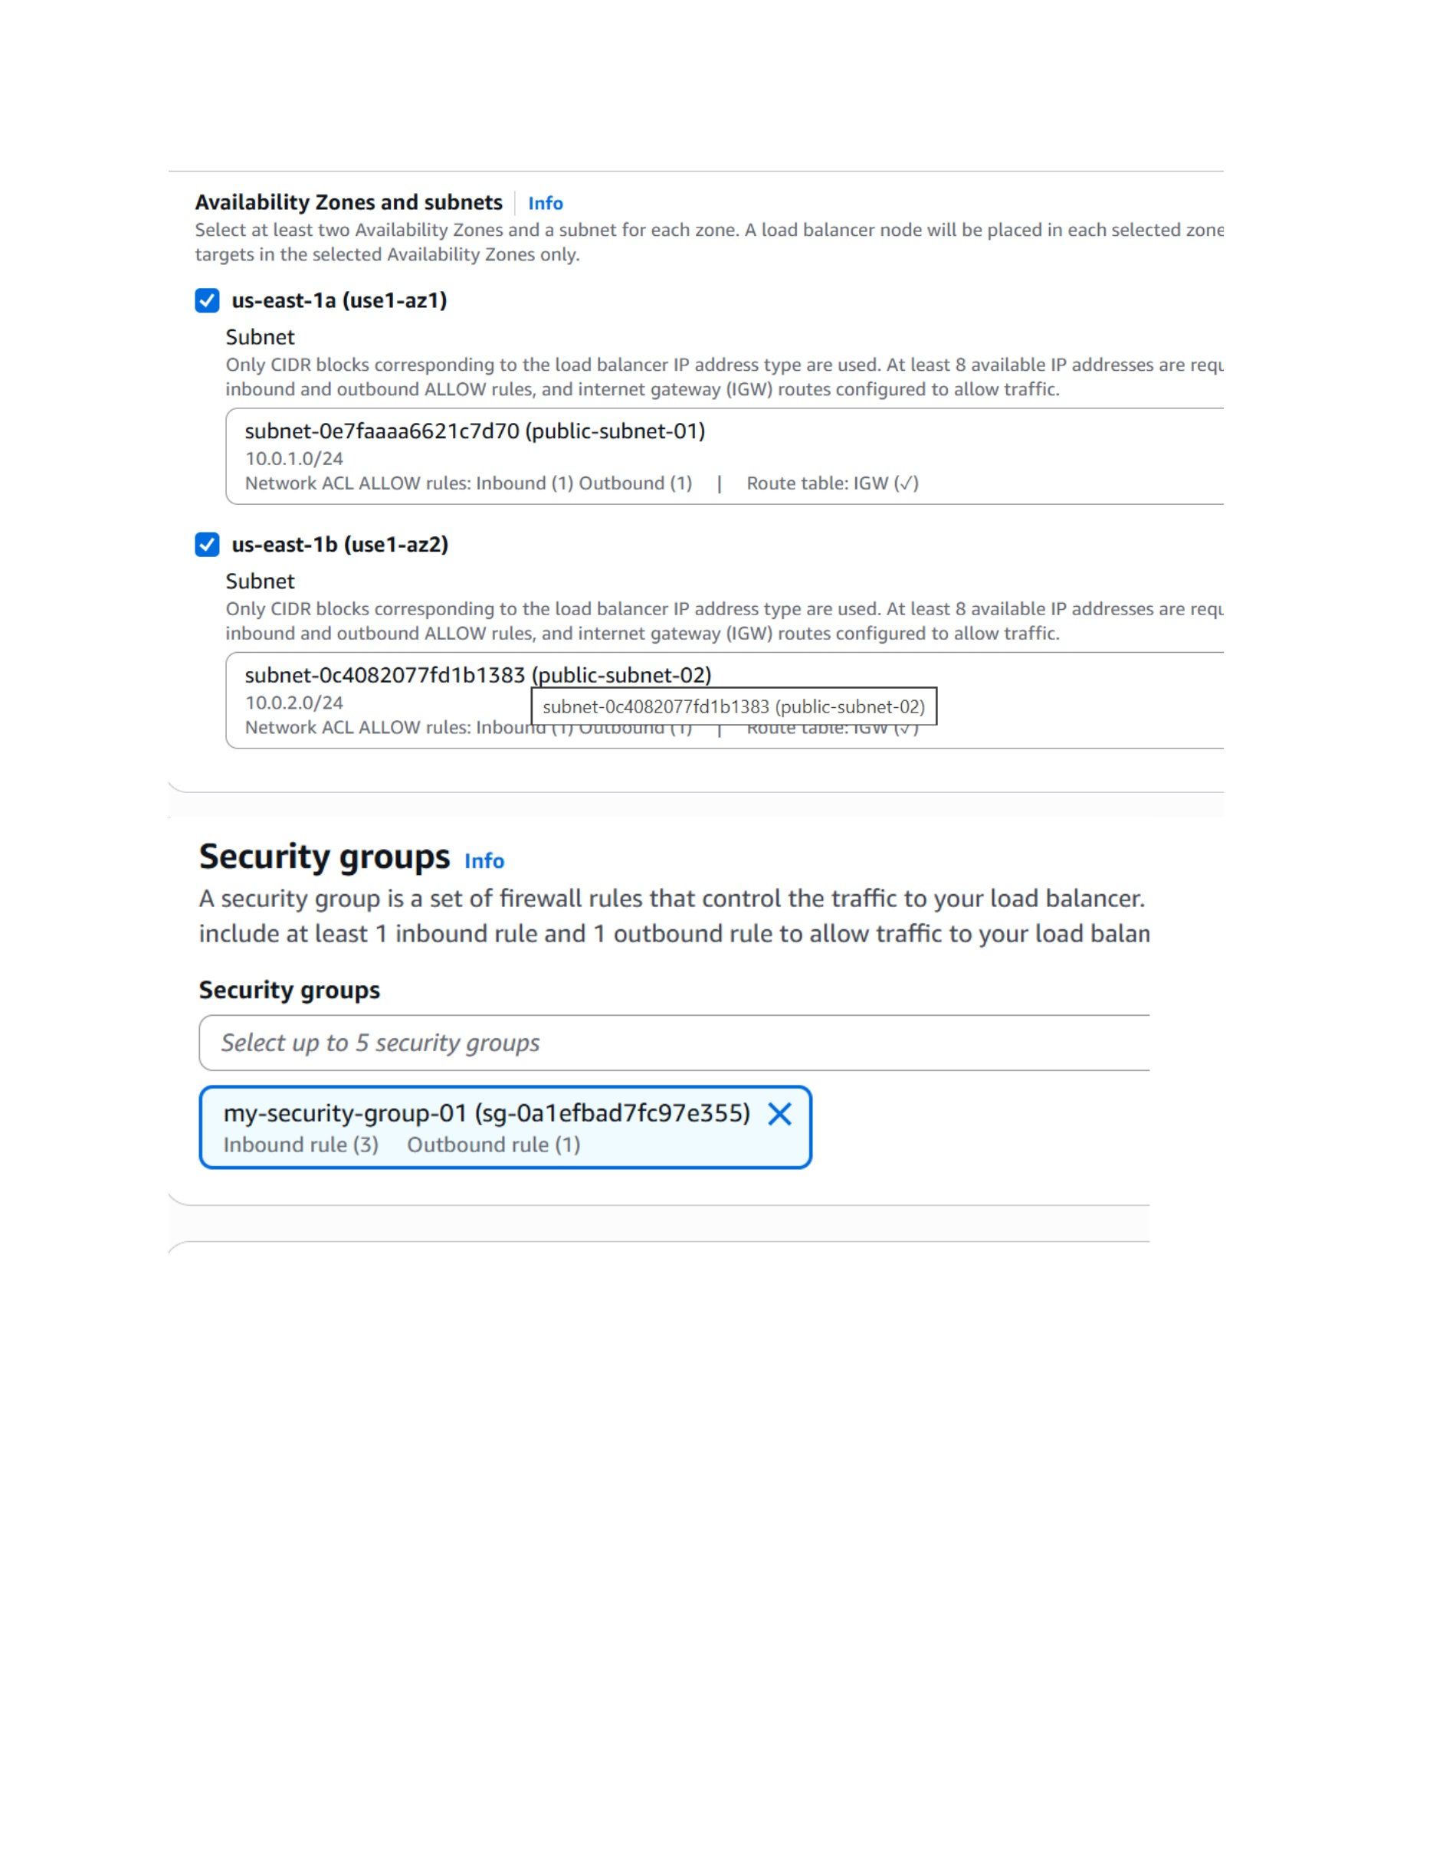
What I did: I selected the public subnets in us-east-1a and us-east-1b for the load balancer.
Explanation: Using the two Availability Zones provides the ALB with network locations from which it can receive and route traffic.

PAGE 28 – Application Load Balancer – Configure HTTP Listener
Topic: Application Load Balancer – Configure HTTP Listener
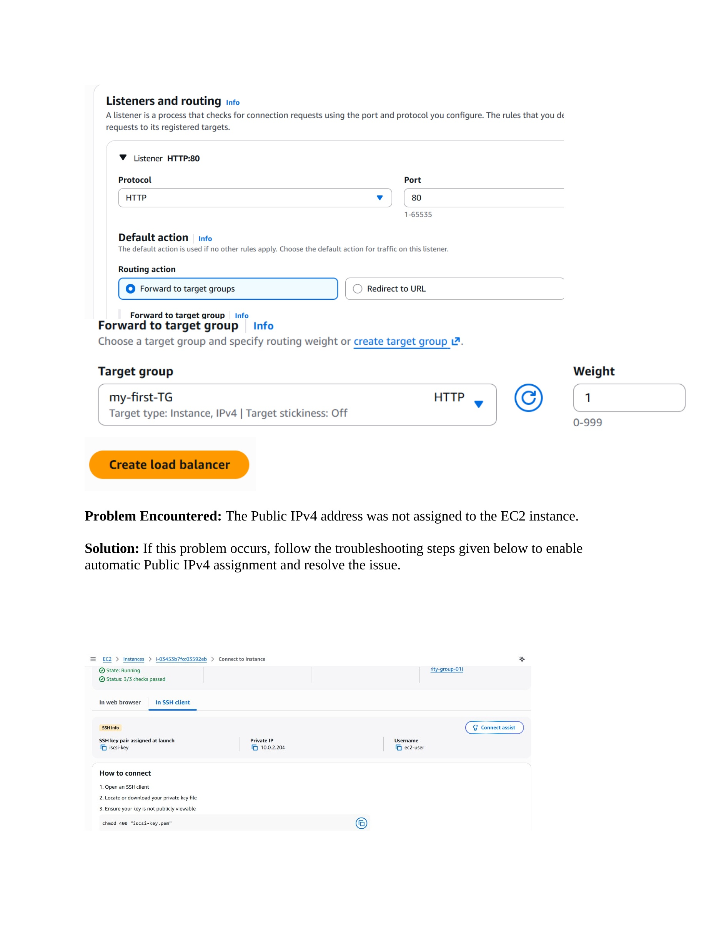
What I did: I configured an HTTP listener on port 80 and selected my-first-TG as the target group to forward traffic to.
Explanation: The listener receives HTTP requests and forwards them to the registered target group.

PAGE 29 – Troubleshooting – Enable Public IPv4 Assignment
Topic: Troubleshooting – Enable Public IPv4 Assignment
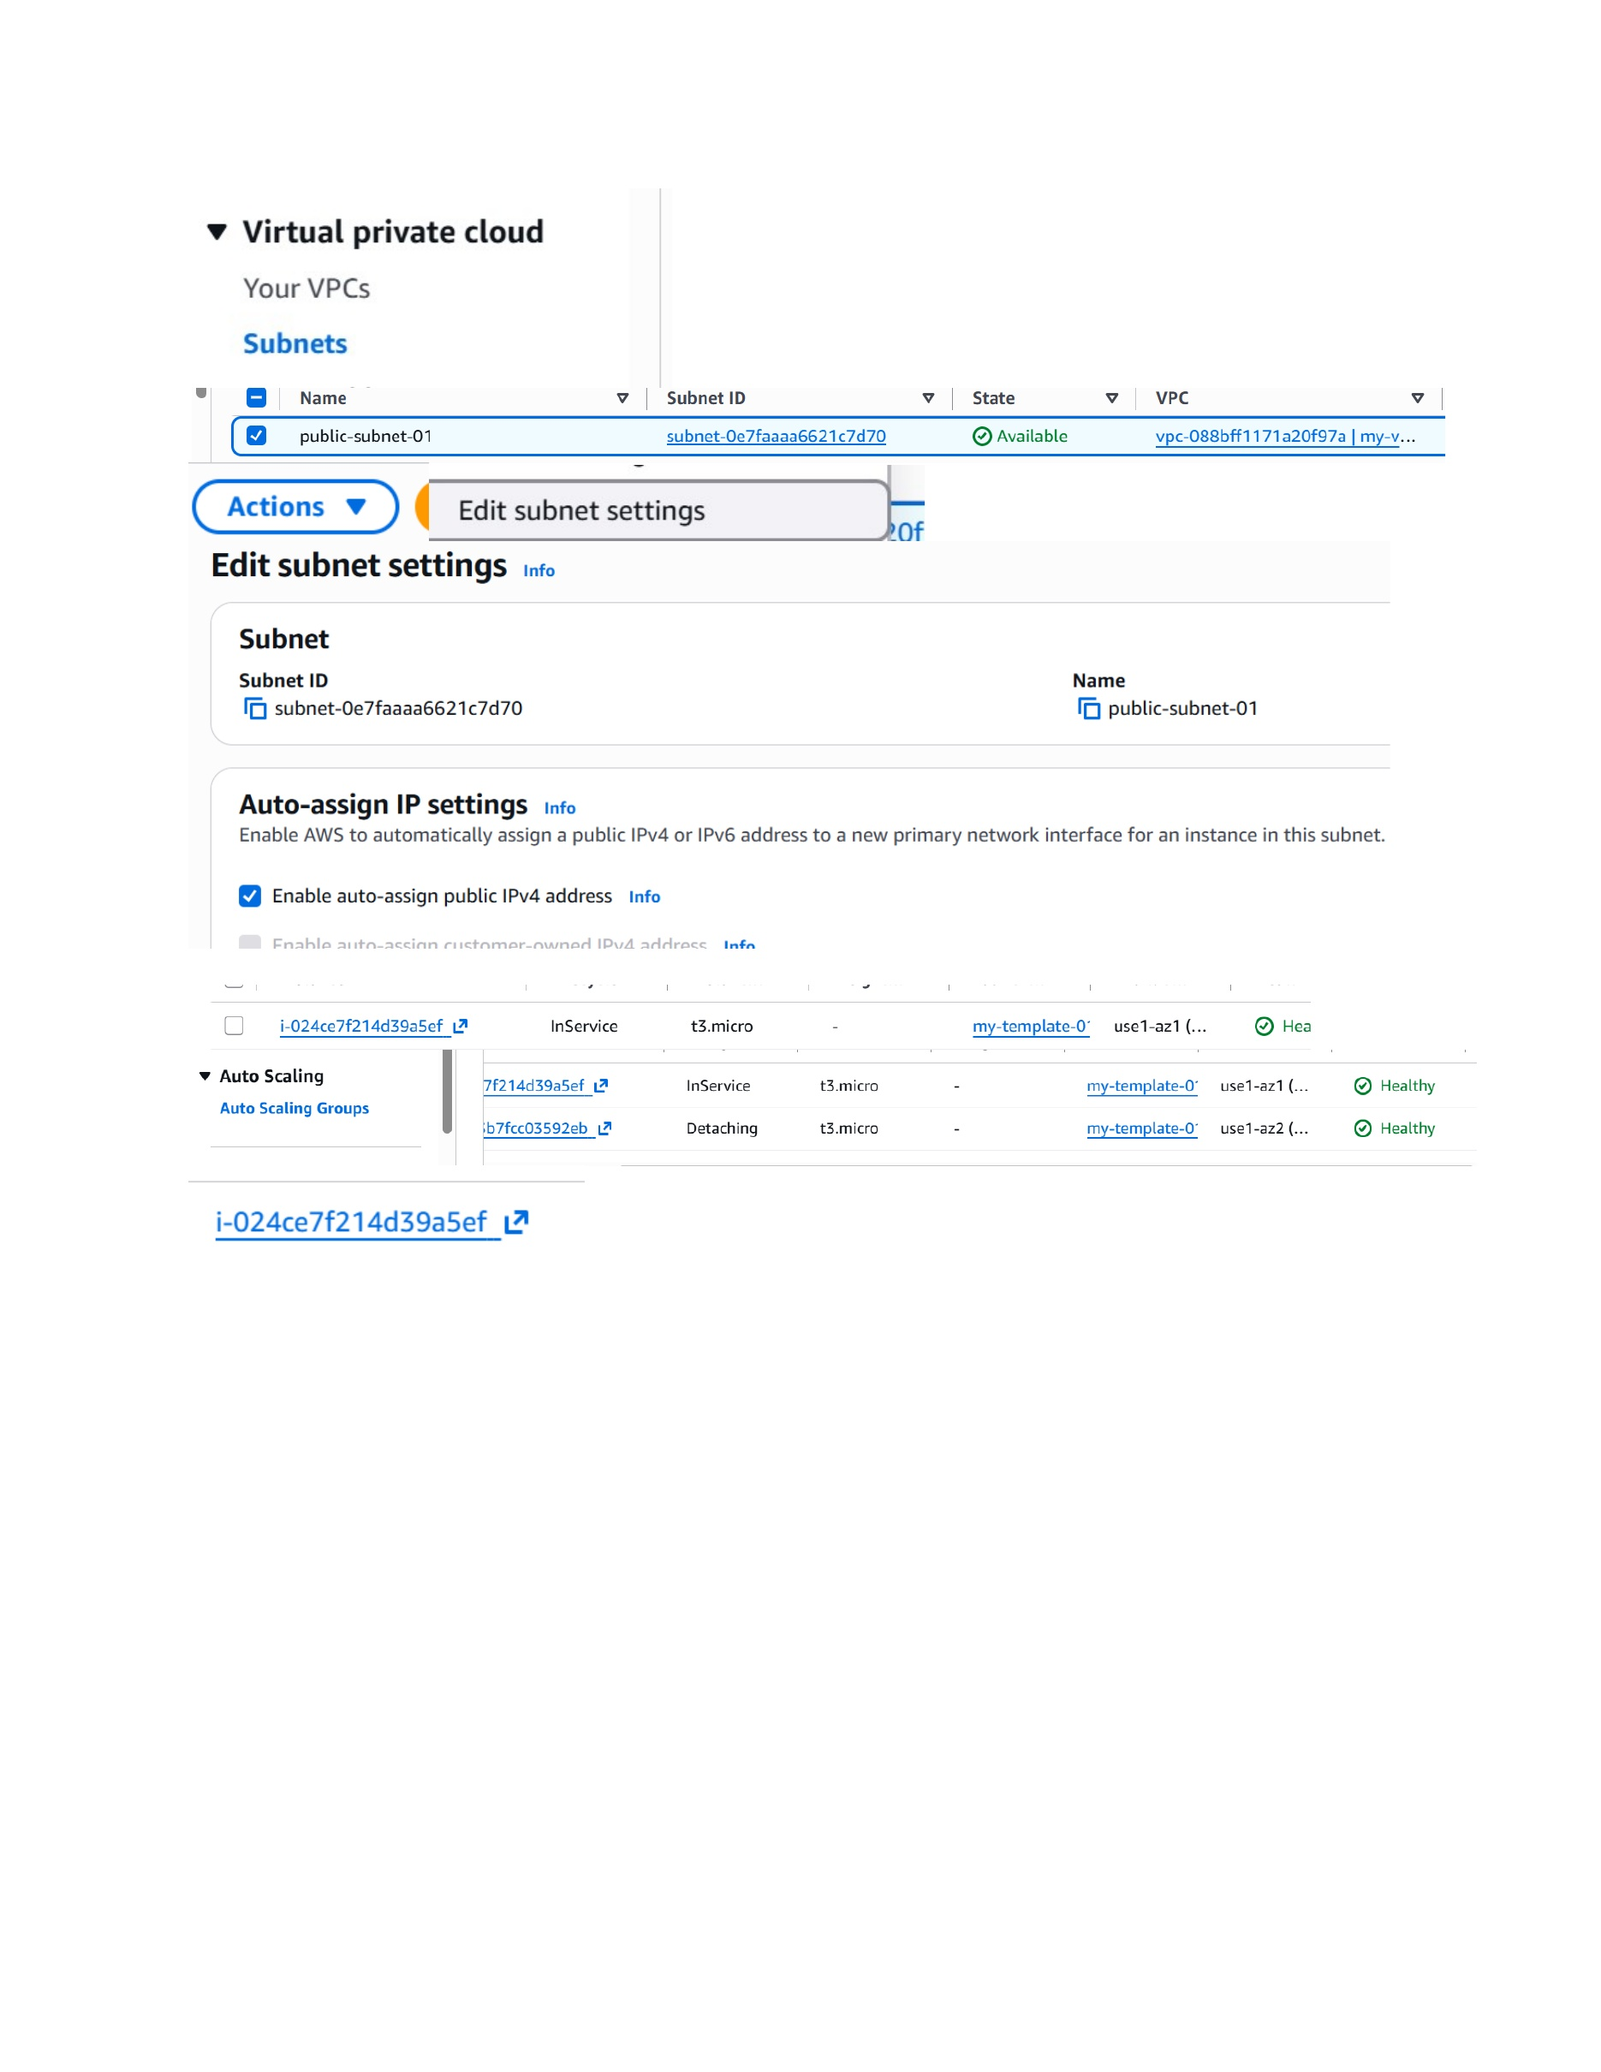
What I did: I opened the subnet settings and enabled automatic public IPv4 address assignment for public-subnet-01.
Explanation: This fixes the issue where a newly launched EC2 instance did not receive a public IPv4 address.

PAGE 30 – EC2 – Verify the Public IPv4 Address
Topic: EC2 – Verify the Public IPv4 Address
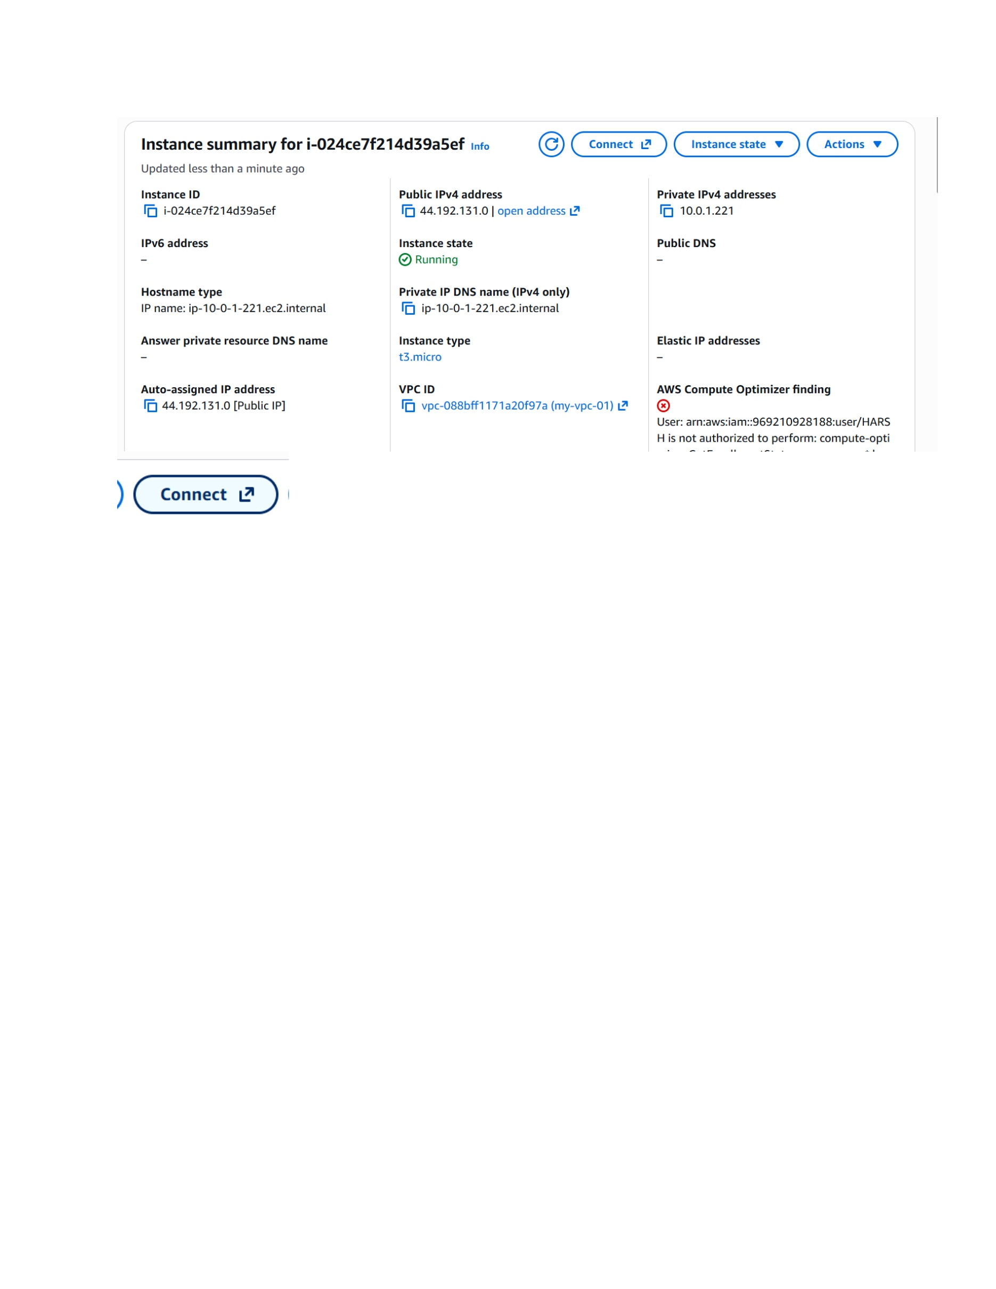
What I did: I opened the EC2 instance details and verified that the instance received the public IPv4 address 44.192.131.0.
Explanation: The instance is running and now has a public IPv4 address that can be used for external access.

PAGE 31 – Website – Verify the IPL Website and Connect by SSH
Topic: Website – Verify the IPL Website and Connect by SSH
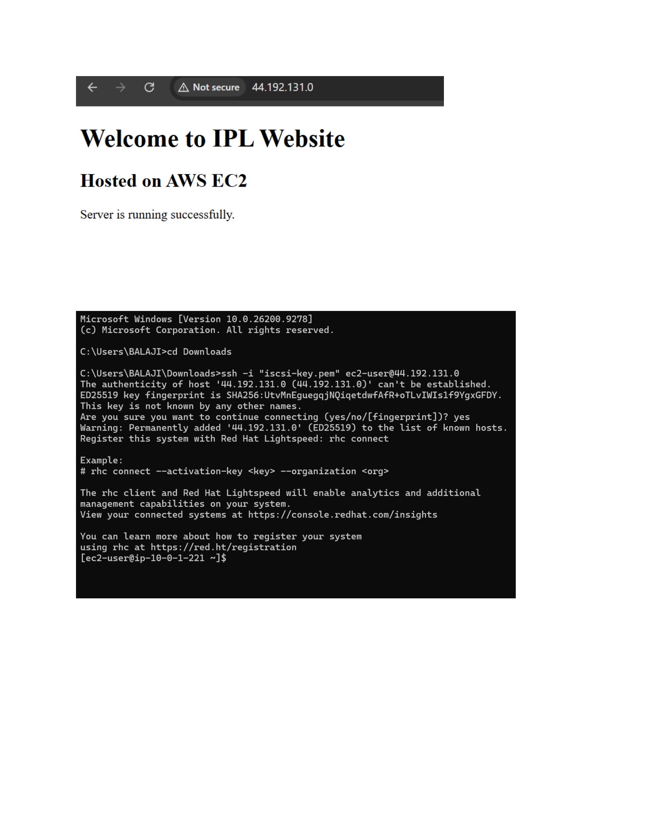
What I did: I opened the deployed IPL website and connected to the EC2 instance using SSH with the iscsi-key.pem key.
Explanation: The website response confirms the web server is running, and the SSH session confirms access to the EC2 host.

PAGE 32 – EC2 – Verify the HTTPD Service
Topic: EC2 – Verify the HTTPD Service
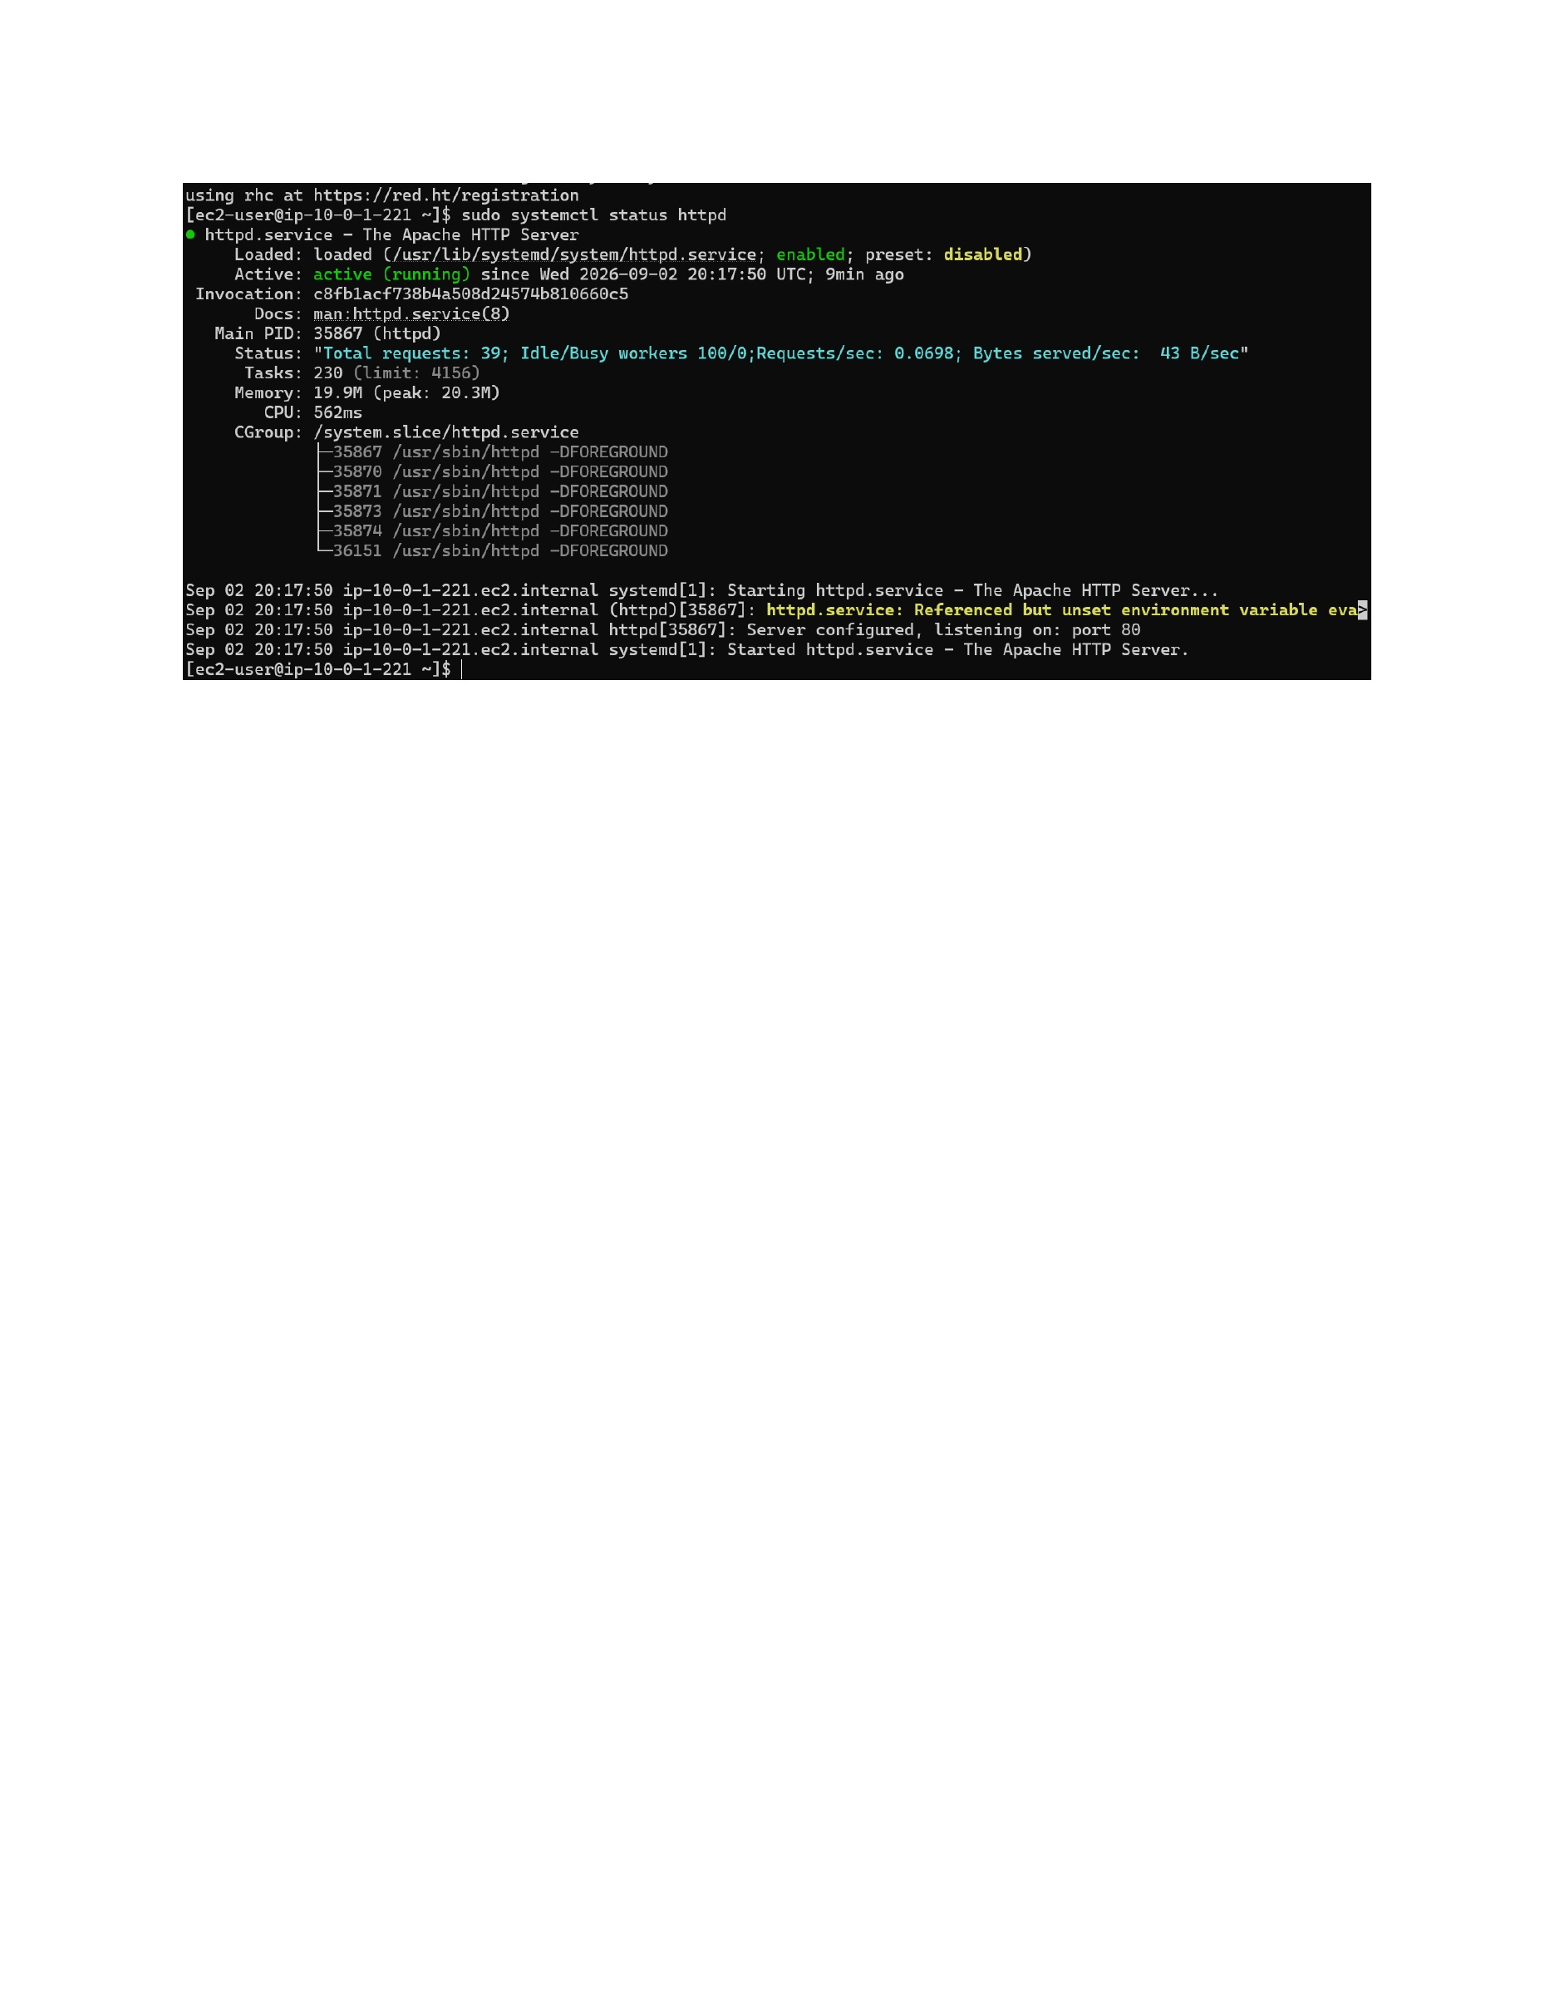
What I did: I checked the httpd service status on the EC2 instance and verified that the service is active.
Explanation: The active httpd service confirms that the web server is running successfully on the EC2 instance.

